February 3, 2022

Casey’s General Store DOAS/Controls wiring

Using an 18/6 wire:
- Run dry run output S1-RA, S1-RB in controls to R and G in DOAS unit
- Run fan speed output S1-S+, S1-S- in controls to U9 (+) and GND (-) in the DOAS unit
- Do not connect wires to S1-FA and S1-FB in the kitchen controller
- Additionally, run a twisted, shielded pair wire from kitchen controls to DOAS unit. Do not land wires as this is for remote monitoring coming later.

*In locations with fan proving only* Follow the instructions below.
1) Install the airflow proving switch in the DOAS unit.
2) Connect the final two wires from the 18/6 wire ran between the kitchen controller and DOAS unit to the airflow proving switch in the DOAS unit.
3) In the kitchen panel, remove the J8 harness from the PCB board (the harness that has blue, yellow, orange, and brown wires on it). Unwire the harness from where it’s terminated.
4) Hook up the new harness into the old J8 port, relanding the blue, yellow, orange, and brown wires to where you removed them on the old harness.
5) With the two new red wires on this harness, connect these to the two extra wires in the 18/6 that is running from the DOAS unit to the kitchen panel using wire nuts.

Electrical schematic shown on the following page to help show connection requirements.

From here, it’s a matter of adjusting parameters on the kitchen panel touchscreen:

1) Go into SETTINGS, enter password (1000), and then navigate to the Factory Settings menu.
2) Enter in Factory Settings, then press up or down until finding “Fan Proving”, and press enter.
3) Change from “No” to “Yes – Supply Only”, and press enter. “Saved” should appear on the screen temporarily.
4) Cycle power to the control panel at this point by locating the circuit breaker feeding the control
panel and turn it off and then back on.

Regards,

Phllip Kraft
Executive Account Manager – WI IA
Accurex - Engineered Restaurant Systems
A Greenheck Company
Direct: 262.227.7865
Phillip.Kraft@accurex.com

Exhaust Fan wiring:

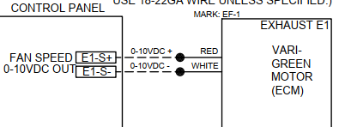

Thermostat Wiring:

