

OPERATING PRINCIPLE
AHU DEDICATED TO PACKAGING AREAS
GMAU26 GMAU27 GMAU28
Nestlé Mt. Sterling - Kentucky

Introduction:

The AHUs foreseen for the project have been sized and approved for construction by the Engineering company Power Engineers.
The packaging rooms classified Medium Hygiene at Mt. Sterling (Kentucky), will be served by AHUs 3 star with Freecooling design which integrate a desiccant wheel.

Target of the room by project is 45°F - 60% RH during normal production.
Aim of the design is to meet the particular needs highlighted by the customer, and particularly the need to dry out the fastest possible after the washing to then return rapidly in production with all the room.
For this reason, during the drying the desiccant wheel has been foreseen to send air with an absolute humidity of 7 gr/lb. During the normal operation (with or without free cooling), the set point of the absolute humidity gets changed, exiting the wheel and taking it to 15.5 gr/lb of supply (standard operation).
The various phases can be selected on the HMI in which the operator will set if the AHU is in Running or in Washing/Drying. After having selected the cycle, the type of operation will be chosen:
  - Running
  - Washing
  - Drying
The start of the drying cycle after the washing could be fixed by Timer or initiated by the operator; in the same way, the end of the cycle to take the plant in running again could be automatic or decided by the operator. Similarly to a previous project serving the Line 4 , the HMI of the AHUs will be integrated by the Factory in the main system.

The scheme of the AHU is the following and it is synthetically composed by:
- Air intake and exhaust section
- Mixing external air/return air section
- External Air Pre-Heating
- Filtration section
- Pre-Cooling section
- Supply fan
- Dehumidification section with wheel included regeneration section
- Post-cooling section
- Final Filters section
- Supply Air Section

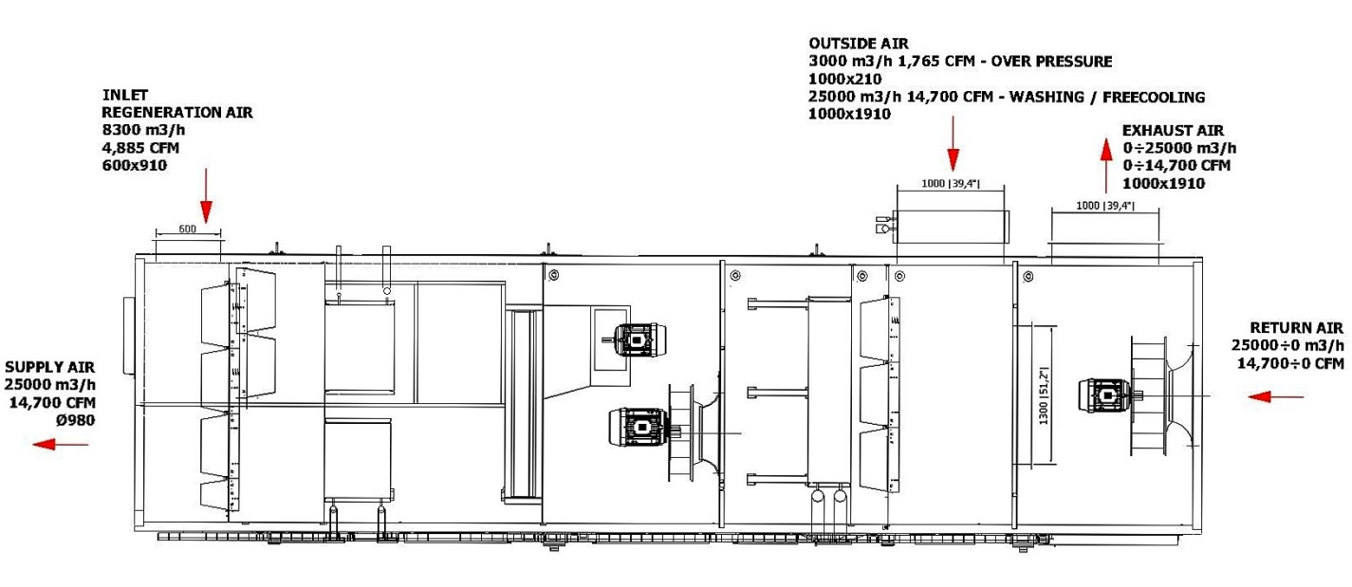

Below are shown the 3D sections of the air handling units in the operation "Running production" both in the case in which there isn’t the enabling of free-cooling and in the case in which it is enabled operation in free-cooling illustrating the differences between the different modalities of operation.

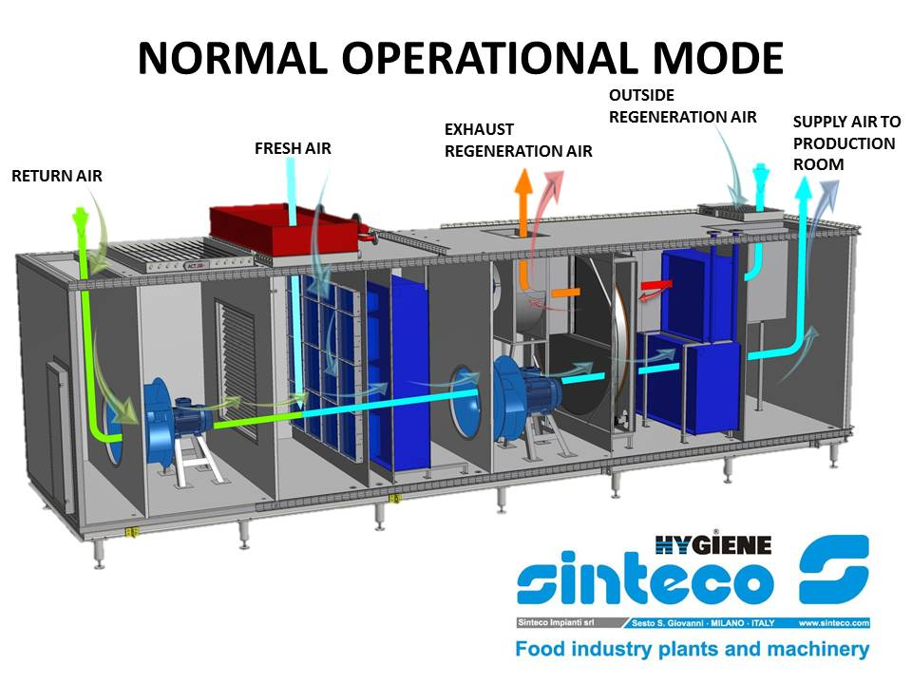

It can be noted that in the operation with free-cooling, there will be an appropriate modulation between "Exhaust air" dampers and the outside air intake "Fresh air" damper in order to save energy while ensuring the planned project conditions in the room.

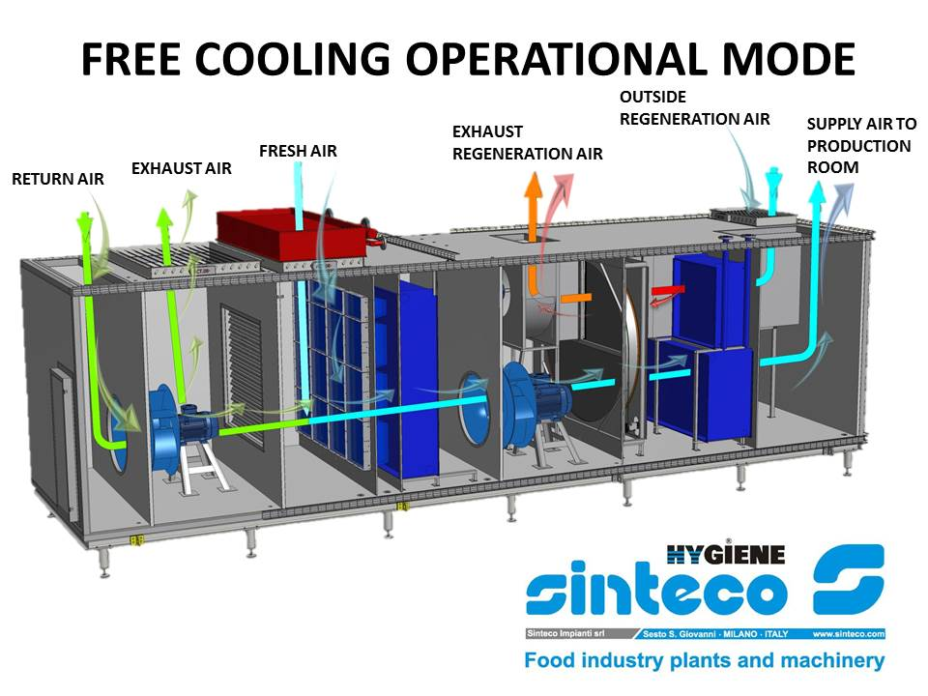
In the next few paragraphs it will be shown the operating principles of the air handling units in the early phases of "Running in production", "Washing", "Drying" distinguishing between operation with or without free-cooling.
Note. An enthalpy probe positioned outside in a protected area, will calculate the enthalpy which activate the Free-cooling operations

Running in production:

The running phase (during the production), has been designed by project to target a temperature of 45°F inside the room, with a relative humidity of approx 60% . There are two types of operation.

- Running without Freecooling
- Running with Freecooling

Standard Running:

The summer conditions are taken in examination, which are the heaviest ones for the post-cooling coil, not only for the temperature but also for the humidity to be taken off from the external air.
The AHU has a total capacity of 14,700 CFM of which the 12% is the minimum outside air (OA).
The return air (12,935 CFM at the temperature of 45°F and HR estimated at 60%) gets mixed with the 12% of assumed external air (summer condition) at 95 °C with the 43 % of RH. After going through the filtration and the pre-cooling coil (disabled in this condition) the air gets dried by the wheel, warms up to 20-25°C (variable based on the humidity of the mixed air which is formed before the wheel), it gets cooled down afterwards by the post-cooling coil. The supply temperature after the post cooling coil will be approximately 34°F (variable anyways from the room set point temperature of 45°F in the room, regulated by the room temperature probe) and with a content of water in the air of 15.5 gr/lb (< 2,2 g/kg).

NB: The pre-cooling coil should not operate during the normal summer operation because the Temperature of the mixing air between the return air and the external air is rather low to allow a good operation of the desiccant wheel without the necessity of pre-cool the air.
The regulation logic of T of the room may be performed through the PLC. It will be regulated by the Temperature of the room (detected with the appropriate T/HR probe, installed in the room) and based on the necessity, it modulates the valve of the post-cooling coil. There will be a set point to operate the precooling coil if the temperatures will require it.
The RH regulation in the room can be done in two different modalities (selectable from the operational panel):

The absolute humidity probe installed downstream the wheel, maintains constant the content of the water in the air (AH less than 15.5 gr/lb in normal operation) modulating the steam regeneration regulation valve. The HR could also be lower than the set of the room.

- The relative humidity probe (HR) installed in the AHU modifies, through the PLC, the set point of the humidity from the wheel, adapting it to the requests of the room itself . While in automatic, the regeneration regulation steam valves will modulate the T of the air to maintain the humidity to the desired values.

Running " in production" - Free-Cooling mode:

The second case has a considerable part of the air in the room exhausted and replaced with external air.
This condition results positive in winter due to the low temperatures and humidity (which take to a considerable saving on the quantity of consumed cold glycol), lower than the room, limiting in this way the energy absorption.
NB 1: The pre-cooling coil in Running does not operate.
When it is operating in free cooling mode, the regulation of T and HR of the room remains inserted, therefore it continues to modulate the post-cooling valve and the regeneration of the wheel (if necessary).
In particular, even if the T of the mixed air would be at 34°F but the absolute humidity (AH) is higher than 15.5 gr/lb, the wheel could work to lower the AH under 15.5 gr/lb; that causes heating of the air of few degrees (depending on the humidity) so then the operation of the post-cooling coil to return the room at the T of the set point.
NB 2: The wheel continues to rotate in all operating conditions, only the regeneration Temperature could vary, based on the AH upstream.

Washing mode:

During the washing in the room the T and the RH will be high and, in order to avoid to dirt the ducts, it is appropriate to exhaust the air by the dedicated fan, foreseen by the project ( by others) It is foreseen a dry contact from the Control panel , to activate the fan at the activation of the Washing mode
The capacity of the exhaust fans has to be calculated for a minimum of 5 volume/h. It
During the washing mode the AHU processes only external air.
In the summer season the external air ( by design T=95°F and RH=43%) will be processed by the pre-cooling coil then it will be warm up through the desiccant wheel.
The pre-cooling coil allows to reduce the temperature and absolute humidity in order to arrive to the desiccant wheel from which comes out with an absolute humidity of 15 gr/lb.
The air flow on desiccant wheel will have a temperature of 53°F while it will have a temperature approximately of 54°F off a desiccant wheel, with an absolute humidity lower than 15.5 gr/lb.

In the winter season the external air will be processed by pre-heating coil in order to have the appropriate supply room temperature and an absolute humidity lower than 15 gr/lb. In this case the desiccant wheel is normally not working.

Free-cooling during the washing:

It is possible to enable the free-cooling when the enthalpy of the internal air (to be verified during the first washes after the start up) is superior to the external air enthalpy. If we assume that the room would be at 68°F with a RH of 95% (data probably lower than in the reality) when the external air enthalpy is lower to approx. 50 kJ/kg (precautionary data in regards to the 55 kJ/kg of the assumed room conditions), it’s convenient to go on full exhaust and operate with Free-cooling at 100%.
If the external air temperature entering in the mixing room is > 50 °F, the operation of the pre-cooling coil will be enabled to take the temperature downstream of the same coil at 50°F. Under the 50°F, the pre-cooling coil is disabled.
If the temperature of the external air is lower than 40°F (T chosen to have a warmer air in supply), the pre-heating coil will be enabled to take the air at 40°F.

Drying area mode:

After the washing, the entire room is dried with extractor kept ON for some minutes, to evacuate the moisture as much as possible
During the drying, the AHU operates sending air with a content of water down to 7 gr/lb to dry the room in the shortest time possible. The supply temperature can be regulated through the post-cooling coil.

Freecooling during the Drying:

Presuming realistically to maintain the room at 68°F and 50-60% RH the freecooling is enabled (100% Free-Cooling) when the enthalpy is lower than 40 kJ/kg (situation with 68°F and 50%).
Some cases are then highlighted:

External T> 43°F: when the external air temperature is higher than 43°F, the pre-cooling coil is enable to take the air to 43°F.

External T < 41°F°C: when the external T is lower than 43°F the pre-cooling coil is disabled; if the external air temperature goes under 41°F, the pre-heating coil is enabled which heats at 41°F.

NB: During the washing, the T° /RH probe in the room must to be protected to avoid its damage, it has to be recommended in the procedures that the probe has to come back in operation after the washing and at the beginning of the drying.
Important Note: The necessary measurements on site will be performed in the commissioning phase and according to the actual operating conditions (especially during Washing and Drying) the values of set point described in the document could be subject to changes in order to adjust the regulation of the AHU at the actual operating conditions of the system.

SINTECO IMPIANTI S.r.l.

