Summary:
Day one: first thing done on site was to interview the manager and staff to determine a time line. After interviewing the staff it appears that the hood capture issue has been ongoing for at least the last 5 years. Per the staff member that has been here the longest the hoods and grease ducts were thoroughly cleaned pre 2019 and for a brief period of time hood capture was adequate. Next while cooking was occurring hood capture was observed to be in the 60% to 70% range. This was confirmed with several smoke capture tests with multiple 45 second smoke candles. After the initial smoke capture test was completed each individual filter was read out with a velocity matrix which totaled out to 4144 cfm of exhaust.
Day two: EF-1 (utility fan) was inspected. The unit was running at 6 amps out of and FLA of 9 amps. The motor per the captiveaire hmi screen is running at 70hz out of a maximum of 75hz with a static pressure at the unit of -3.5” implying there is serious obstruction in the ductwork. Make up air was also read out and inspected, with total make up air being 3487 cfm when the ductwork was traversed and 2502 cfm at the diffusers infront of the hood out of a design of 5120 cfm. After the MUA was inspected and read out the ductwork above ceiling for EF-1 was inspected. The static pressure at the clean out door immediately before the duct leaves true foods space is -1.1” which is significantly lower than what was read on the roof. There is also grease build up in the ductwork. The following images are of the exhaust fan and ductwork on the roof.
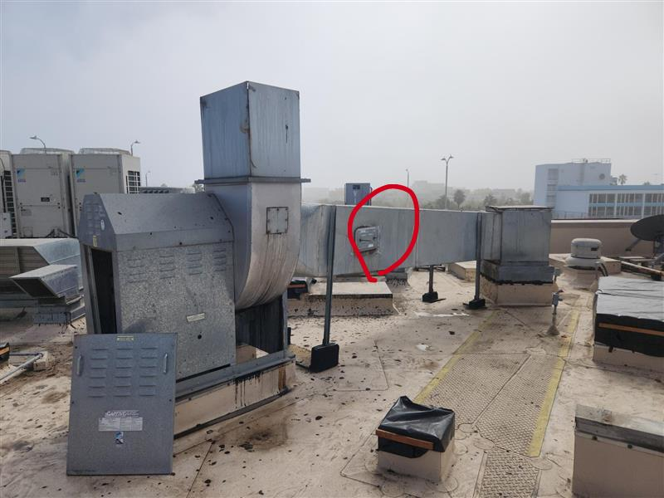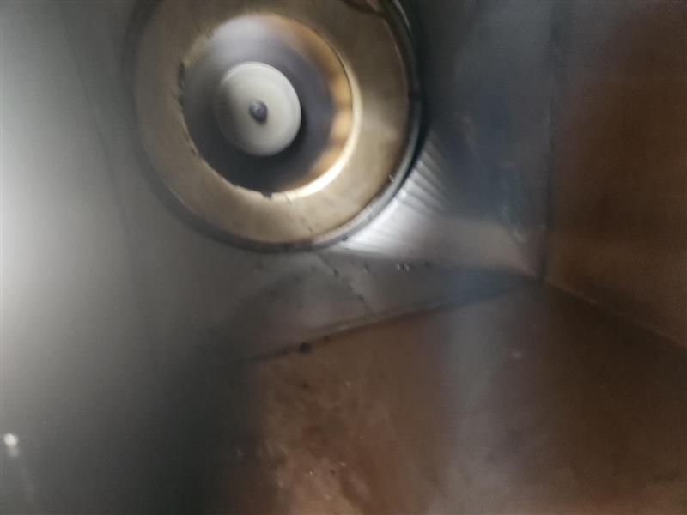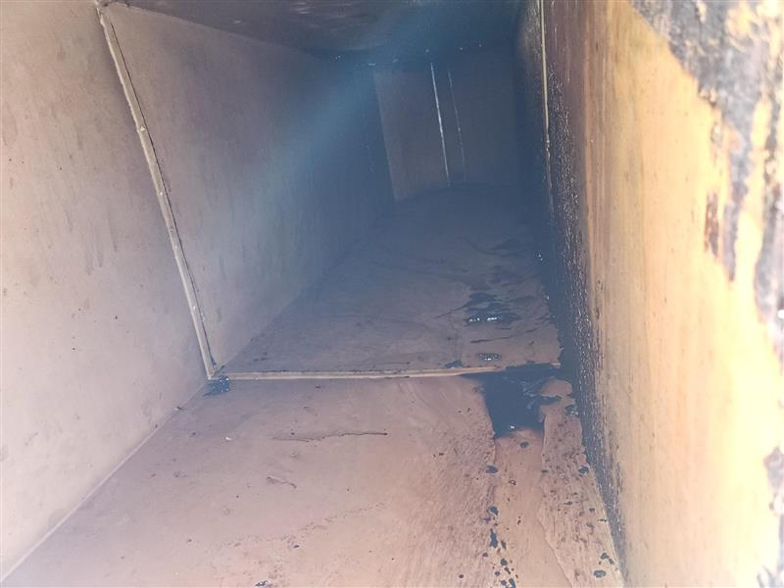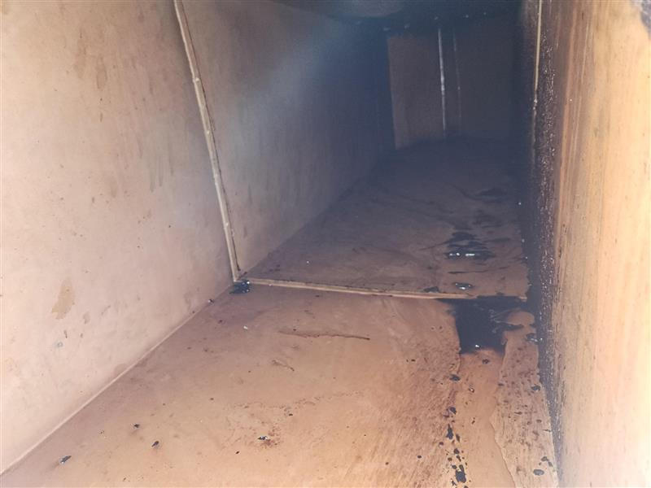
The following images are of the ductwork inside true foods space
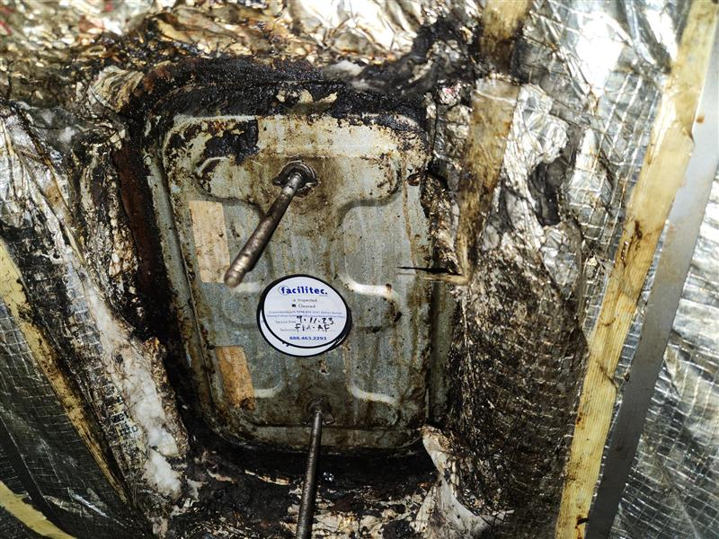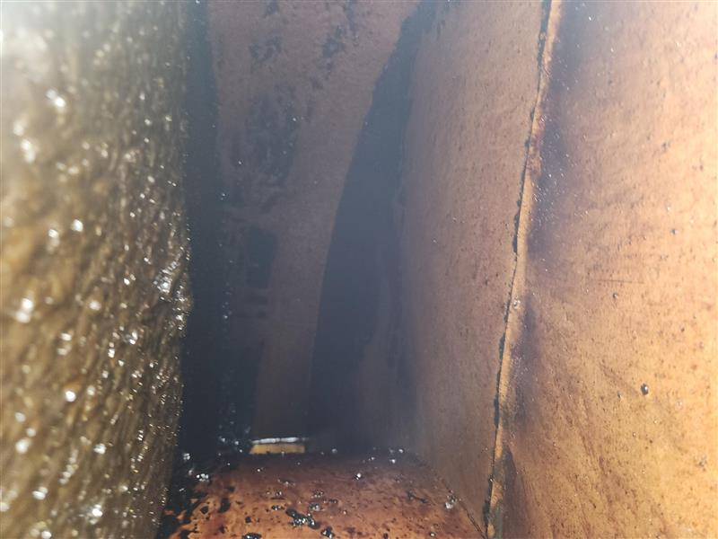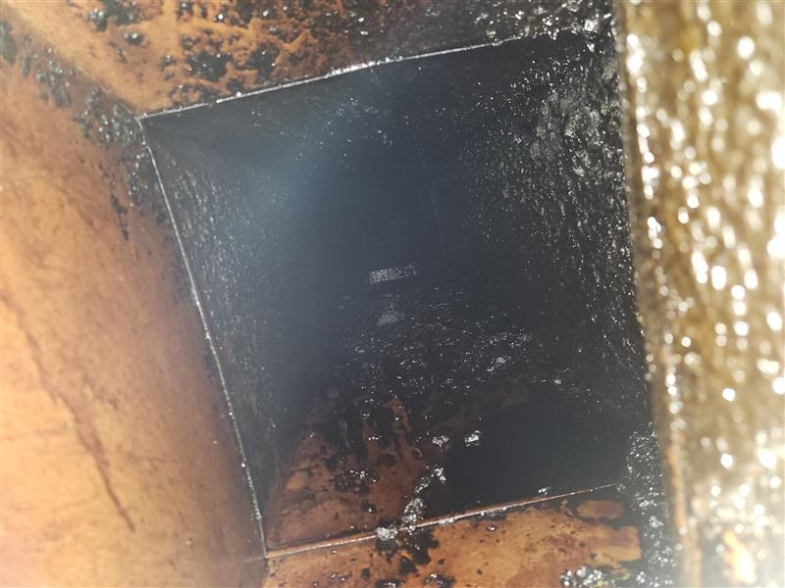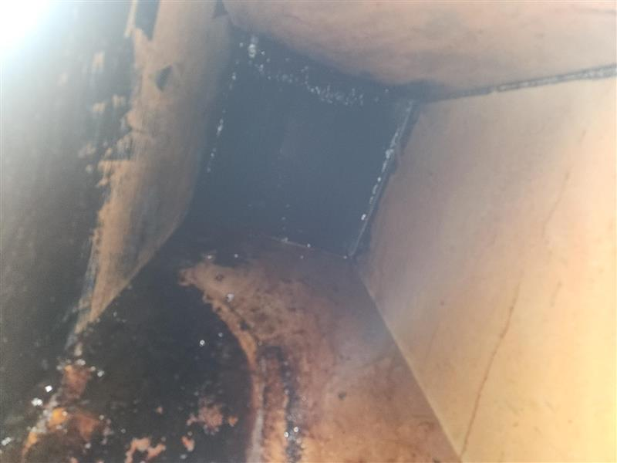
Day 3: entire exhaust duct run was inspected except for the second floor section of ductwork. From visual inspection and pressure testing at clean out door it was determined that there are and where from 6 to 8 90 degree transitions in the duct run. With statics on the first floor being -1.2” and statics on the 3rd floor being -3.4”. there is also about a half of an inch of grease build up at the 90 degree transitions (see attached photos)
First floor ductwork: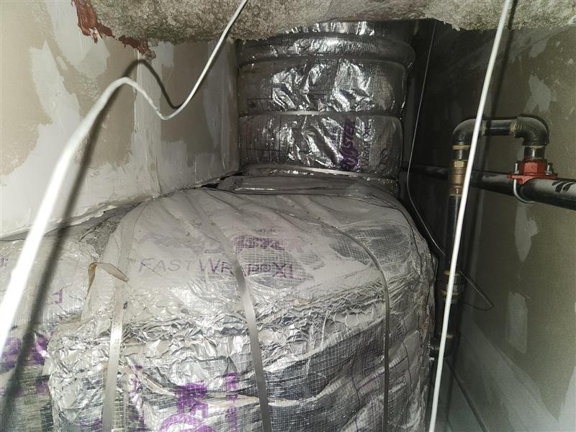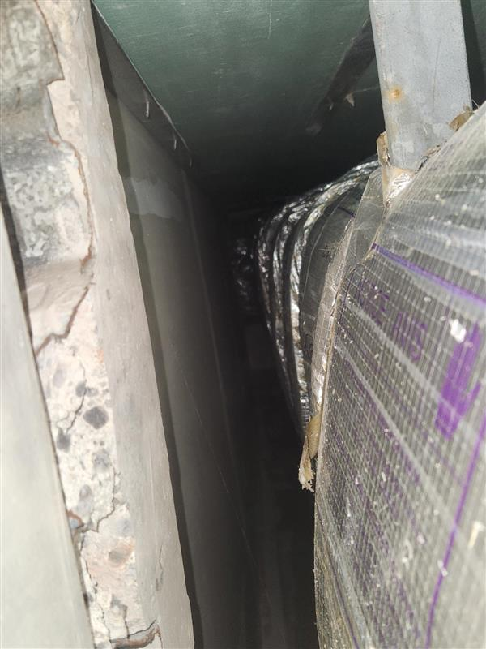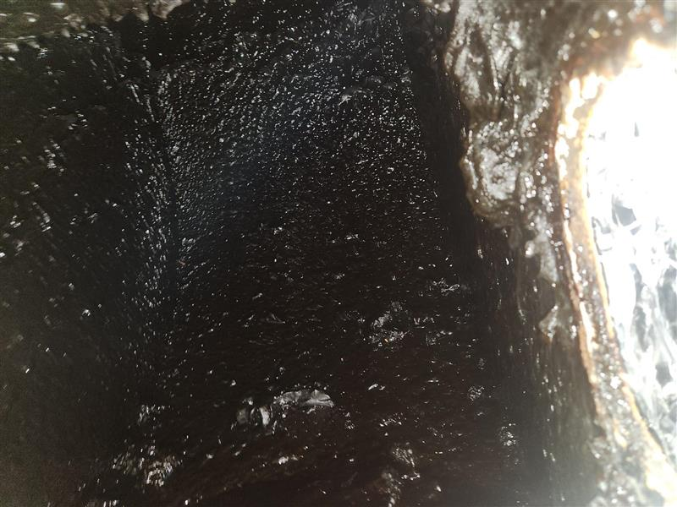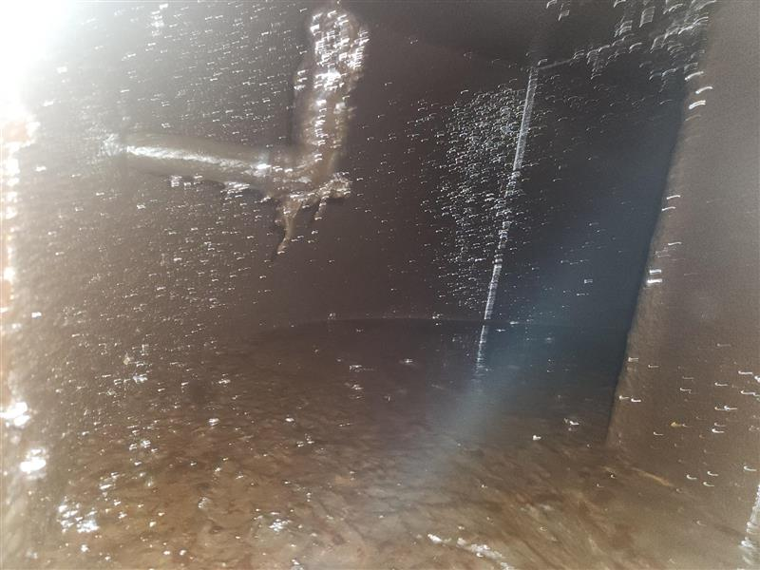
3rd floor ductwork: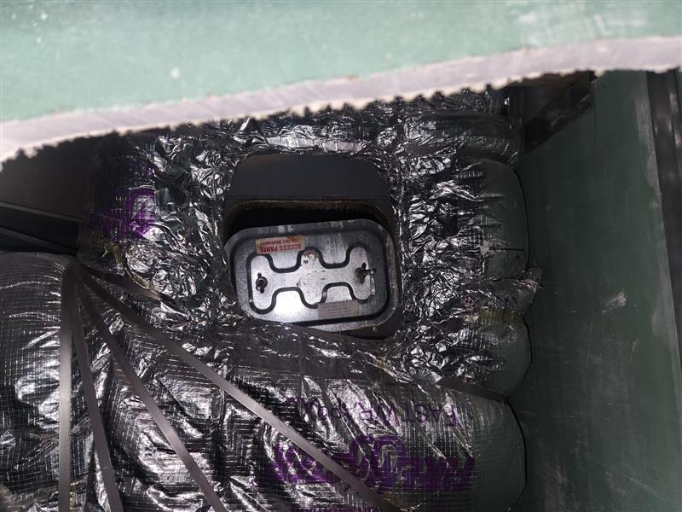 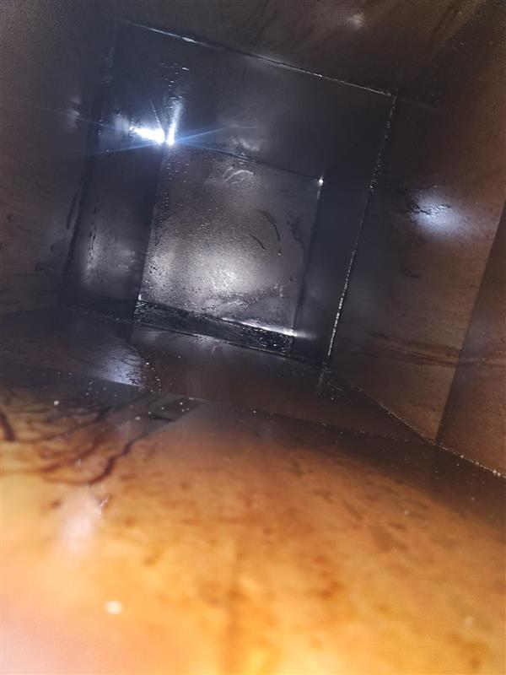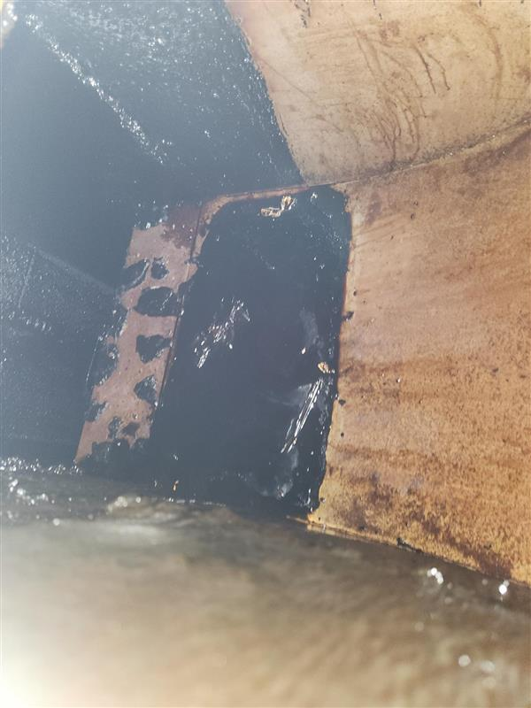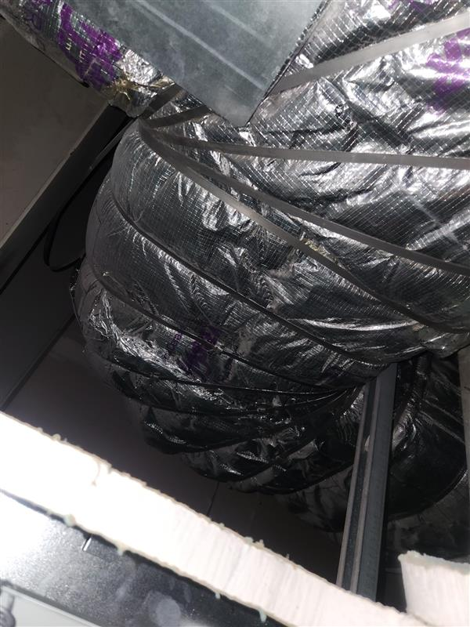
Hood capture was also tested with mock end panels. this improved hood capture by about 10%.

Recommendations:
- Low Volume exhaust due to high pressure losses from multiple 90 degree transitions with multiple back to back that create higher static & additional airflow losses due to system affect. A new (larger) fan could be utilized to try to overcome the static & system losses to get to design. However the pressure is already high at lower volumes so the pressure could double trying to get 6000 CFM. A typical 90 will have 0.2" to 0.35", most of the ones in picture look to be closer to 0.35. As you increase velocity in the duct, the higher the impact due to system losses. Either way, It looks like a larger fan is needed. But there may be a need to have some of the ductwork changed (modified) if we cannot overcome the back to back 90 degree transitions to get optimum performance.
- Need end panels installed on both sides of the hood due to walkway & shelving above appliance.
- The shelving & salamander above the equimpment creates more adverse effects on hood performance at the cooking surface. Especially the shelving that is over equipment & then continues to the left to go outside the hood. All smoke under shelving will travel left & continue out of the hood & then into space. The shelving needs to stop 12" from left end of hood & then at least partial end panel-30" wide & down 6" below the shelving in hood.
- Verify diffusers in front of hood not impacting performance, but from inspection they do not appear to be effecting capture based upon smoke test. It looks like the make up airs high velocity in several areas are creating a curtain in front of hood which helps on diffuser interaction with hood. However, its too strong & impacts capture at lower level. Either install larger supply plenum (18" wide possibly) or if you can duct mutliple ducts off supply & install additional Perforated diffusers in ceiling to difuse the air more.
- For good performance the Average filter velocity needs to be at minimum above 150 FPM & based upon layout & cooking with charbroilers & woks really need to get closer to 200 FPM minimum

