Shake Shack – Chesterfield, MO Commissioning Kick-Off Meeting

Introduction:
Shake Shack has initiated an MEP & Sprinkler Commissioning program. The purpose of the program is to increase quality control and equipment performance through a step wise program that is lead by a commissioning agent (CxA) assigned to each project. Below is the outline of the four sections we created to organize our efforts.
Section 1: Communication Plan.
- Definition of commissioning
- Team
- IOS/Android Communication Platform (optional for trades)
- Issue and RFI reports: Trigger conditions and resolution process
Section 2: Current Schedule of events
- Phase I field inspections
- Phase II site readiness and commissioning activities
Section 3: Phase I field inspections Scope of work
- References used for inspection
- Typical Inspection scope
Section 4: Phase II FPT scope of work
- Site and equipment readiness
- FPT acceptance test general scope

Section 1: Communication plan
Collaboration & Communication
- Kick off meeting Video [date and time)]
  - What is commissioning: Process to assure all systems and components are designed, installed, operating, and perform to the owner requirements

- Team identification and roles
  - Owner - CxA
    - General Contractor - CxA
      - Mechanical & TAB team - CxA
      - Fire Sprinkler / Fire suppression - CxA
      - Plumbing - CxA
      - Electrical - CxA
      - Lighting – CxA

- Communication platform: FaciliBuild HUB
  - The platform (IOS / Android native application) can be downloaded on your phone or tablet. National TAB’s team will contact you to see if you prefer to use this method and if so, we will walk you through a quick onboarding process to get you registered and connected to the project where you will have access to:
      - All team members and contact information
      - Host all required digital checklist (FIV and FPT’s)
      - Host all issue/RFI items
Issue reports are generated during the field inspection (FIV) Phase I scope, and during any failed FPT of equipment/systems.
Process for Issue resolution, Issue(s) are created for reasons below:
      - Not installed
      - Not Installed to plan/schedule/spec/submittal/detail/special provisions (code-OEM requirement)
Resolution: GC will be issued a report at the conclusion of the inspection, and if available, made aware during the inspection. CxA will follow-up with GC to ensure the issue has been resolved.
RFI Reports are generated during the same inspections and are created for reasons listed below:
      - Condition cannot be met
      - Local AHJ supersedes Design
Resolution: RFI will be discussed with GC then sent to Engineer of record to accept or detail response which may require new shop drawings should major deviations in system layout occur.
Team Page
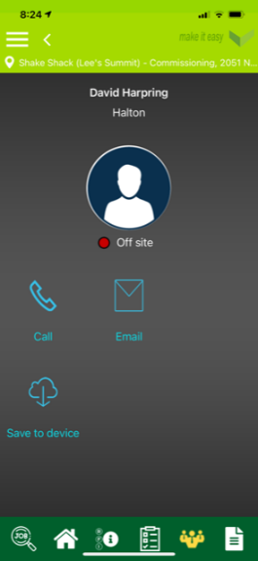
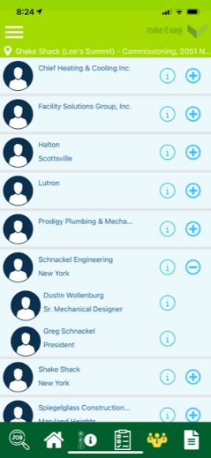

Checklist
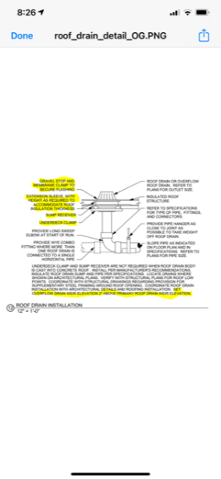
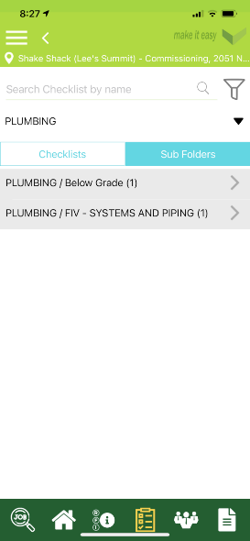
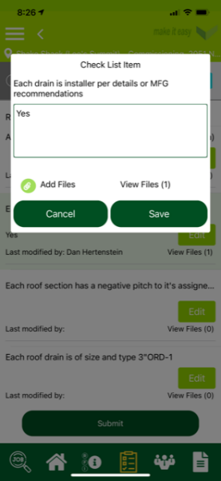

RFI & ISSUES
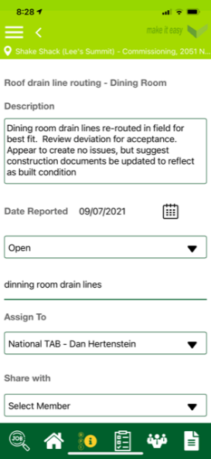
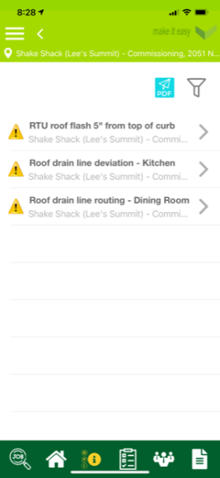
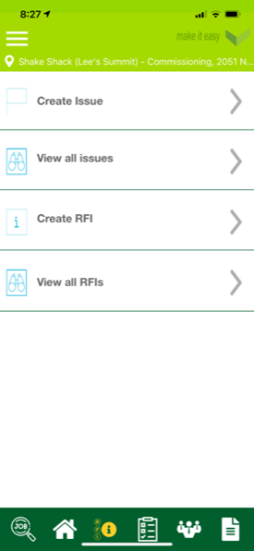

Section 2: Current Schedule of Events
Schedule of Events:
- Phase I: Field Inspections (FIV)
Description | Performed by | Date | Condition for Inspection
Weekly GC Meetings | GC | Weekly (recurring) | None
FIV1 Below Slab Inspection (P/E) | Commissioning Agent | TBD | Lines complete. Drain lines under pressure for inspection.
FIV2 In-Wall Inspection (P/E) | Commissioning Agent | TBD | All In-wall lines complete, domestic lines under pressure for inspection. Within 3 days of in-wall inspection
FIV3 Above Ceiling & Roof Inspection (All) | Commissioning Agent | TBD | All above ceiling work complete – within 3 days of above ceiling inspection

- Phase II – Readiness and FPT testing
Description | Performed by | Date | Condition for CxA Activities
Issue Reports 100% resolved | CxA / GC / TRADES | TBD | Complete
Startup Reports | GC / TRADES | TBD | Complete
TAB Completed | National TAB | TBD | Complete
Commissioning (HVAC) | CxA | TBD | -
Commissioning (Plumbing - all) | CxA | TBD
Commissioning (Electrical/Lighting) | CxA | TBD | -

Description | Performed by | Date
Warranty documents, O&M’s, Equipment Tags | Trades/GC | TBD
Owner Training completed | Trades / GC | TBD
Final Commissioning Report | CxA | TBD

Section 3 – Field Installation Verification Scope (Phase I – FIV inspections)
Field Installation Verification: Specified Materials, Routing, Size, Supports

- Inspection References:
  - Construction set drawings
    - System layout
    - Details Schematic
    - O&M Manuals
    - Specifications
    - Local AHJ Requirements

- FIV consist of reviewing planned design, details to ensure all items are:
  - 100% installed
  - Sized and routed per plan (any deviation needs to be approved before installation and noted by GC prior to inspection)
  - Installed per details to ensure best practices
  - Installed per specification
  - Properly supported and Insulated
  - Discuss any special local code requirements that may alter installation/details

- WALK THROUGH SITE WITH TRADE / GC TO REVIEW INSTALLATION AND ACCESSORIES INSTALLED ONCE INITIAL CX INSPECTION IS COMPLETE

Section 4 – Equipment FIV and Final FPT Acceptance Testing

Pre-Commissioning Checklist of specified equipment:
- Identification: Matches accepted submittal data
- Installation details: Installed per MFG requirements, design details, and local code
- Operation: Normal and abnormal interlocks and operation
  - Startup reports to be collected
  - City inspections completed
  - Specialized testing completed
- Ensure all open issues / RFI’s created during the Phase I processes have been resolved
- TAB has been completed

Functional Performance Testing:
To be completed by the commissioning agent.

Overview: Each divisional contractor to be available / present on site during their scheduled test period. Anticipate 1-2 hours, but in some cases, this may be reduced based on previous inspections, city test, startups, and functional verifications.

- Final Equipment Inspections
- Normal and abnormal interlocks
- Sensor/Equipment Calibration
- Alarms
- SOO and Communication (automatic operation)
- Performance

HVAC, Ventilation, KVS Systems
A: TAB team shall perform commission on HVAC
- TAB shall perform additional criteria as part of commissioning functions
  - Validate proper location of room sensors
    - Ensure sensors cannot be damaged by water or incidental contact
    - Ensure sensors are not affected by surrounding environment or air drafts so they are measuring a true average of its space
  - Validate sensor calibration:
    - Room space and Humidity
    - RTU Enthalpy and Mixed Air
  - Validate Communication and function of RTU/Room Thermostat
  - Validate stage 1 (Low Speed), stage 2 (High Speed), and dehumidification LAT (High speed)
  - Validate O.A flow, damper position, and Mix Air temperature in high speed

  - Validate O.A flow, damper position, and Mix Air temperature in Low speed
  - Validate Discharge temp in stage 1 heating (low speed)
  - Validate Discharge temp in stage 2 heating (high speed)
  - Validate Economizer function and barometric / relief fan functionality
- TAB shall Perform FPT acceptance testing on Kitchen Hood sequence of controls:
  - Controls SOO
    - Fan on manual - Interlocks
    - Fan on Auto – Interlocks
    - Fire system activated, fan off: SOO, Interlocks and Alarms
    - Fire system activated, fan on: SOO, Interlocks and Alarms
- TAB shall perform FPT on Patio ceiling fans, UH’s, Office Fan Coils, Restroom Exhaust Fan
    - Operation, Function, & Performance
- Review refrigeration piping is complete, insulated, secured and sealed at any roof or equipment penetration
- Confirm proper service access to all HVAC, ventilation, and KVS equipment
Validate City Inspection Reports:
Above ceiling, Grease Duct leak and insulation test, Hood Suppression, RTU smoke detector test
NT shall collect a copy of the following startup reports:
- RTU, Hood system, MUA (heater/cooling), FCU, UH

Lighting System
B: NT shall perform Lutron Startup and commissioning FPT acceptance
- Label all zones, assign naming rules to labels (CB#-Area/display designated)
- Validate zones labeled activate correct areas
- Schedule set per owner requirements for indoor, outdoor and signage

Domestic Plumbing
C: NT shall perform Plumbing Commissioning
- Validate line or booster pump pressure holds with no water flowing
- Validate Aqua stat unoccupied timer is installed and functional
- Validate recirculation pump performance data and on/off function on unoccupied timer and aqua-stat call
- Validate Hot Water Heater Menu setup is correct
  - Create full demand for hot water at all sinks – validate hot water heater demand sequence
  - Measure hot water temperature at each sink to ensure proper sink temperatures
    - Dish, Hand wash, Prep
    - Validate instantaneous response of Hot water
    - Validate 100% demand of hot water holding temperature
- Validate the expansion tank was calibrated to water supply line pressure
- Validate gravity trap primers are functioning (Restrooms, and mechanical room drains)
- Validate piping of filtered water lines is correct

Validate city inspection reports on:
- Backflow Isolation valves - certifications, hydro static line pressure test, rough-in in wall inspection, Final Plumbing inspection
NT shall collect a copy of the following startup reports:
- Water Heater, Booster & HW-Recirculation pumps, Expansion Tank

Roof Drains, Floor Drains, and Vent Pipe’s
National TAB shall perform visual validation of Roof drains, floor drains and vent pipes
- Validate locations, slopes, and installation of roof drains reflects design
- Validate locations, slopes, and installation of floor drains reflects design
- Validate locations, line sizes, and installation of roof drains reflects design
Validate inspection reports:
Below ground inspections, Air pressure leak test

Gas Plumbing
NT shall perform Gas Plumbing Commissioning
- Validate all final connections and regulators are installed correctly
- Validate all equipment has been started up with gas burners/exchangers (visual confirmation)
- Perform 100% demand heat test to ensure no loss of capacity at any gas fired appliance
  - Unit heaters, RTU’s, Cooking appliances, Water heaters.
    - If gauges are provided record appliance gas pressure during this test
Validate Inspection reports on:
- Line pressure leak test, Rough-In, Final Inspection
Verify startup reports
- Food equipment (By FED)

Fire Sprinkler
National TAB shall perform inspections on the fire sprinkler system
- NT shall review all components for installation and piping
- NT shall ensure no tamper or other alarms are active
- Review sprinkler head installation and correct hazard ratings per zone
Validate inspection reports:
- Rough-in inspection, Fire marshal final dry and wet system inspection test, Hydrostatic test inspection

Electrical
National TAB shall perform commissioning acceptance test on electrical systems
- Ground fault circuit interrupters
- Arc fault circuit interrupters
- Breaker panel details
- Breaker panel labels
- Breaker panel CB size
- Appropriate labels
- Surge Protector devices
- Specialty interlocks, contractors, and shunt trip devices

Validate city inspection reports
Below Ground & Transformer, rough-in inspection, Final inspection

