VRF POINTS LIST
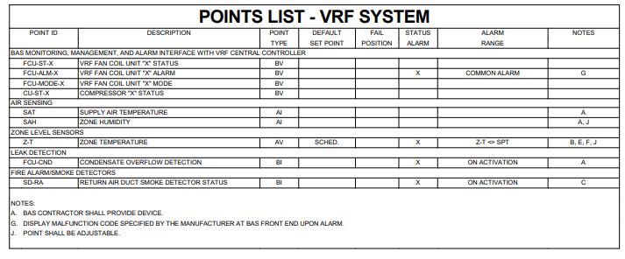

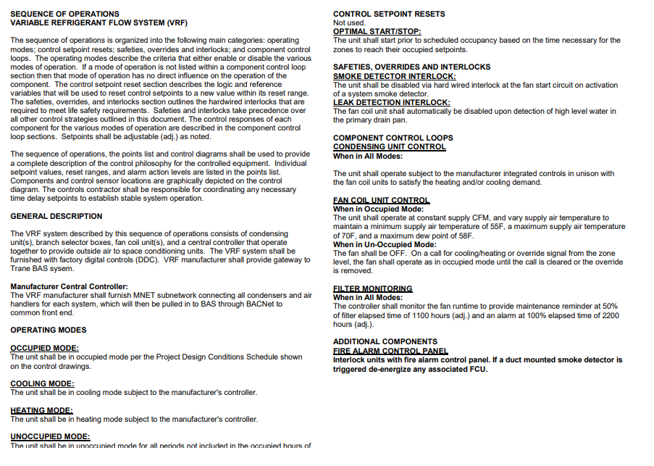
VRF SOO

VRF PIPING CU-6
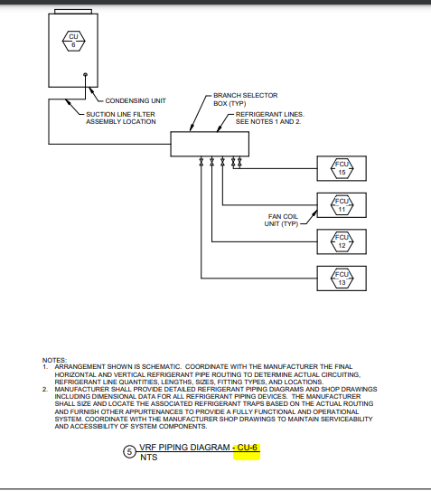

VRF PIPING CU-5

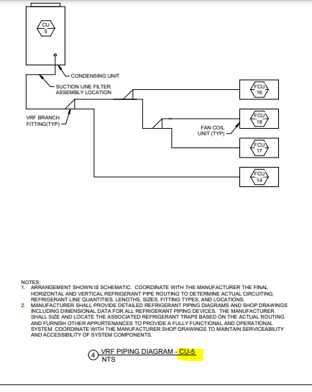

VRF PIPING CU-4
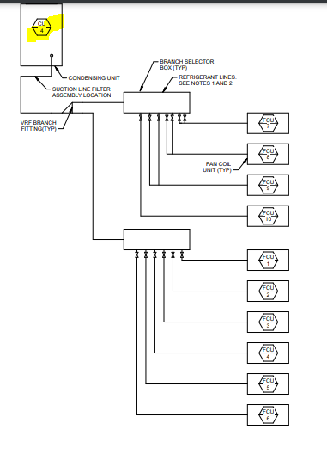
VRF SPECIFIED BRANCH FITTINGS AND HEADER DETAILS
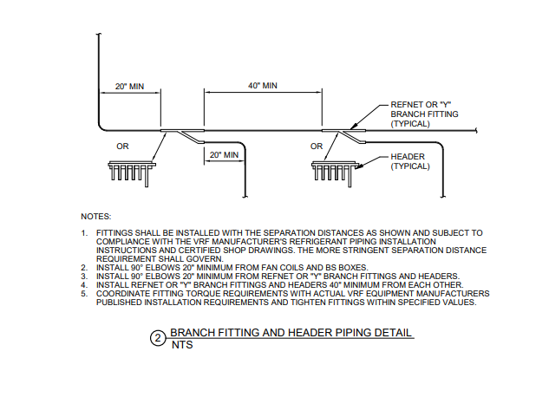

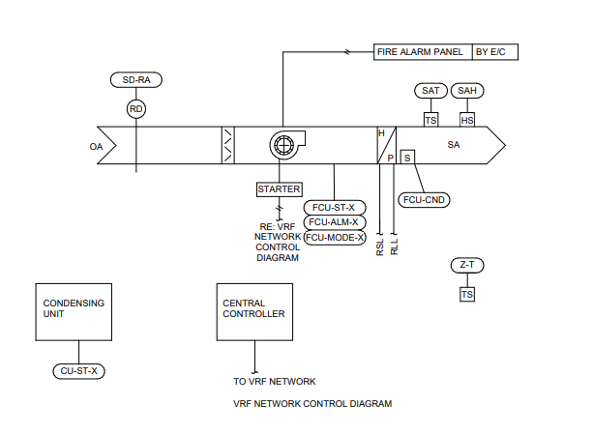
VRF NETWORK DIAGRAM

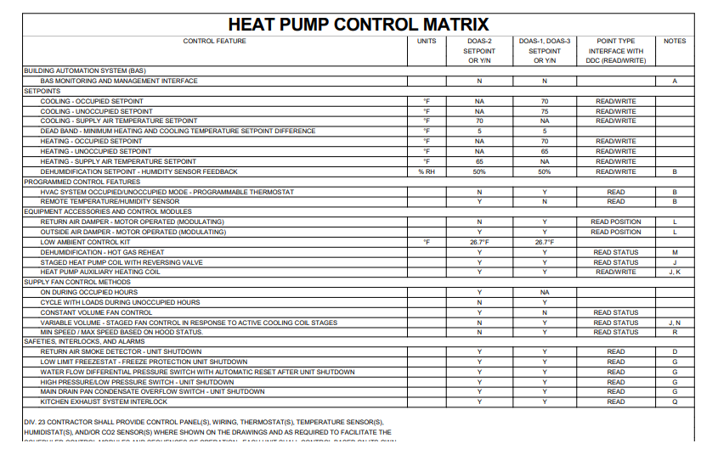
HEAT PUMP CONTROL MATRIX

HEAT PUMP CONTROL MATRIX SPECS
