3/23/2023 return trip to Kroger 025-630 Little Rock AR
- See the engineer’s marked up floor plan that I sent you. The green clouded area got missed on our as-built. Need to sketch on our as-built. When you figure out the duct layout, please take a photo of the RTU that serves the ductwork. Done
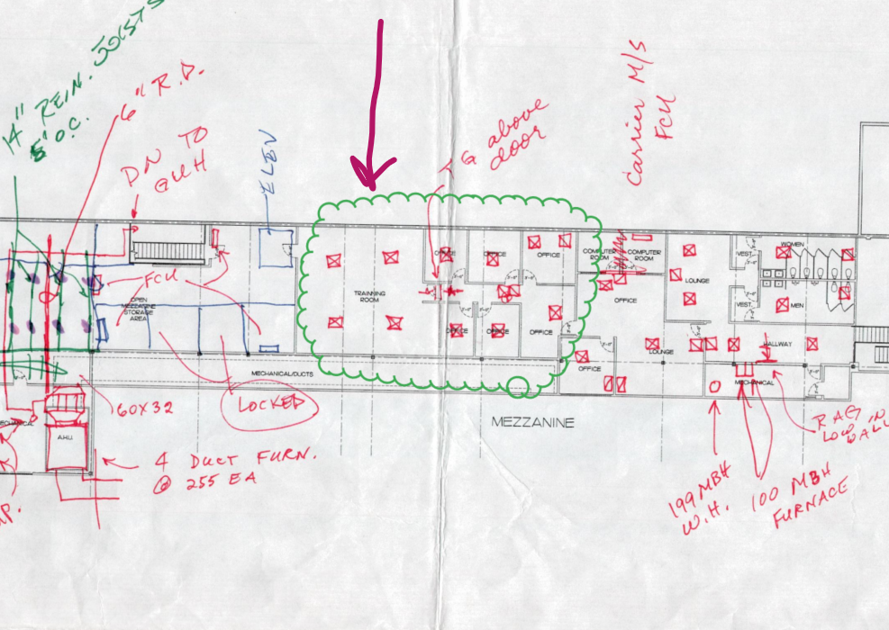
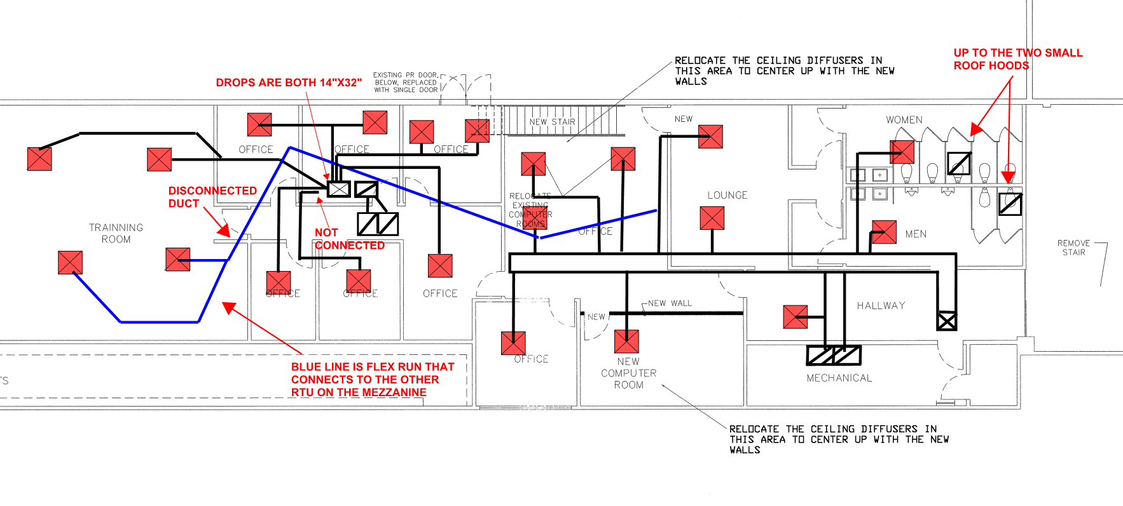
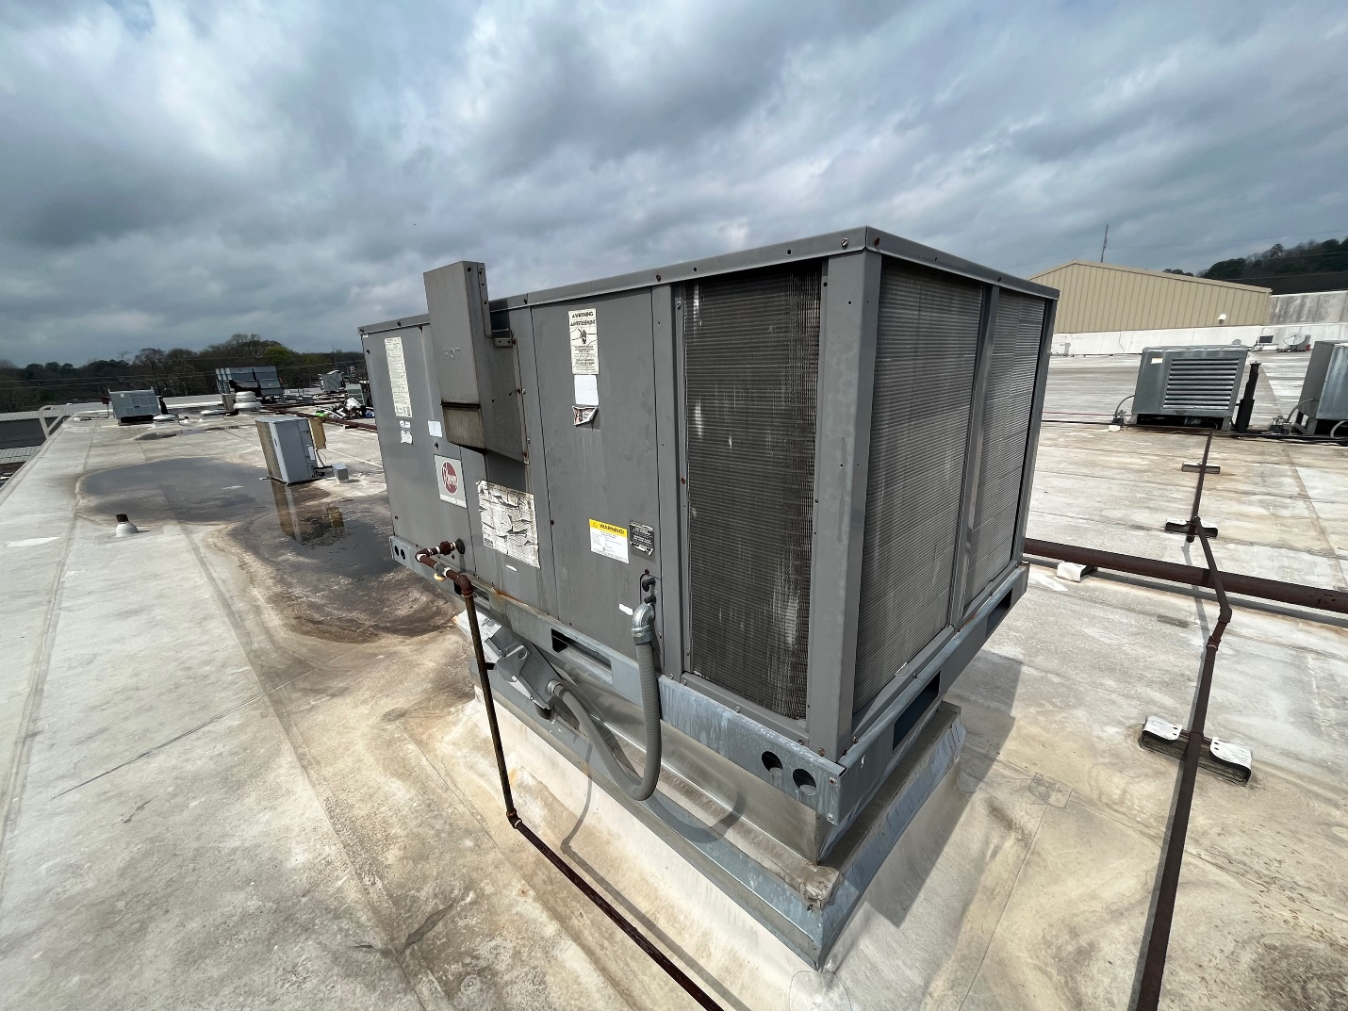
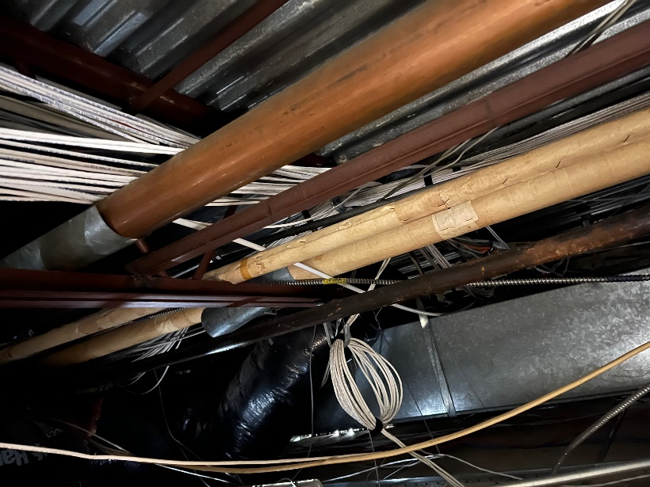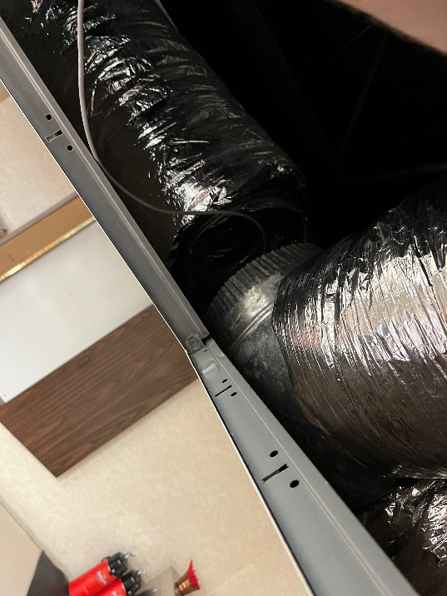
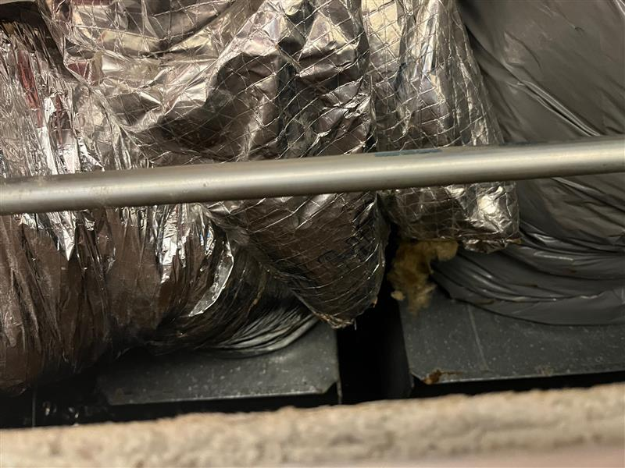
- Screenshot shows a fan and what appear to be roof hoods. They may serve the mezz toilets. Please confirm and measure.
The fan exhaust fan is not on and doesn’t have a belt attached. Fan is sealed to the curb. No duct found below ceiling. Appears abandoned. The two small roof hoods are connected directly to the exhaust duct of each restroom in the mezz with flex duct. No fan found
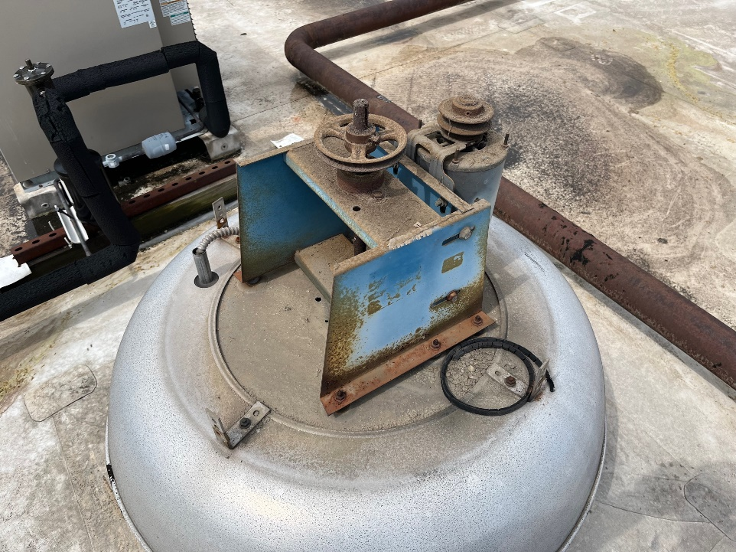
- Please mark up any duct that serves the mezz toilets on our as-built. Done. See above
- See pic below. what’s the airflow at the Make-up fan? Sketch duct on as-built if not shown.
The MUA is not powered. Wires to motor are cut. Ductwork is stubbed above the ceiling.
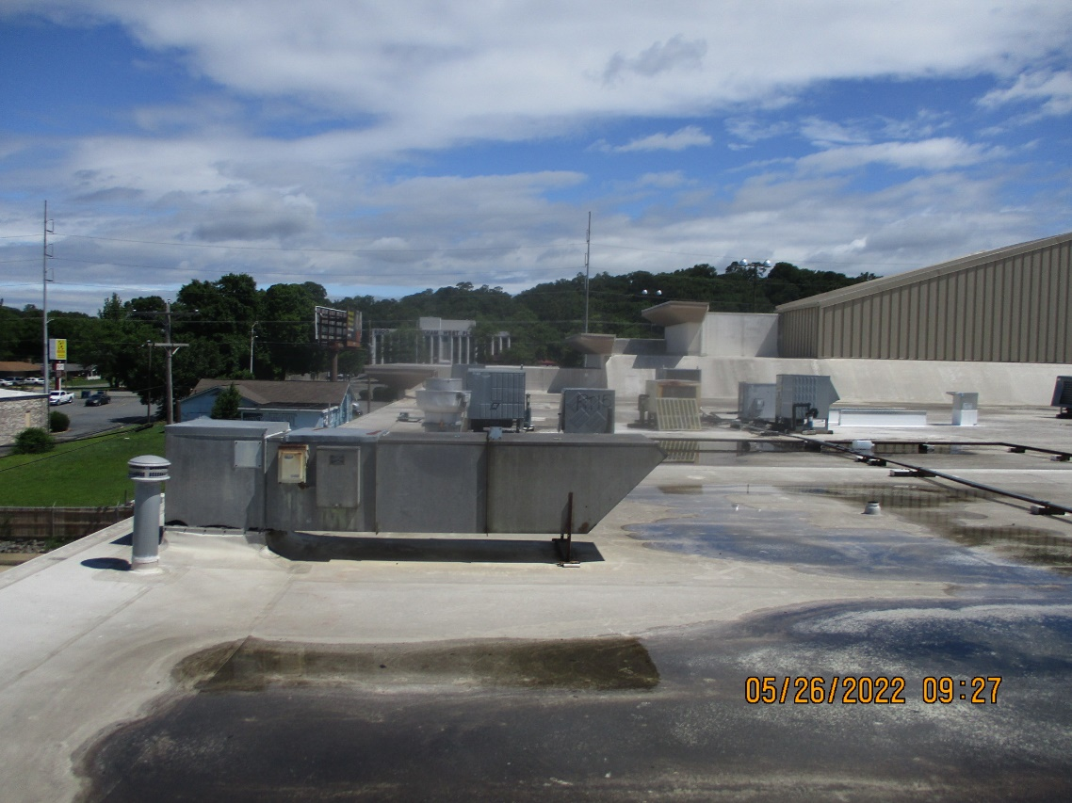,
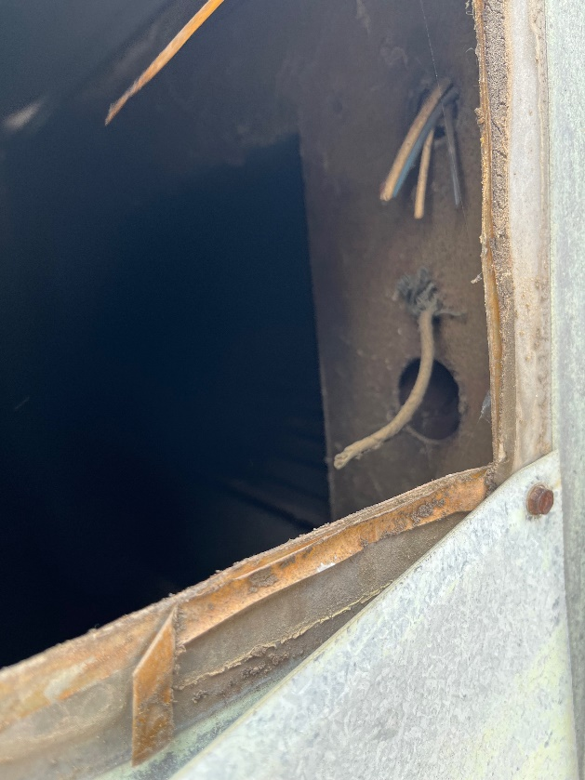
- please determine if the “rear of the store” RTU in the attached photo is abandoned, or if it serves anything
The unit is attached to one diffuser in a side room that is full of trash. The unit itself is not powered and appears abandoned.
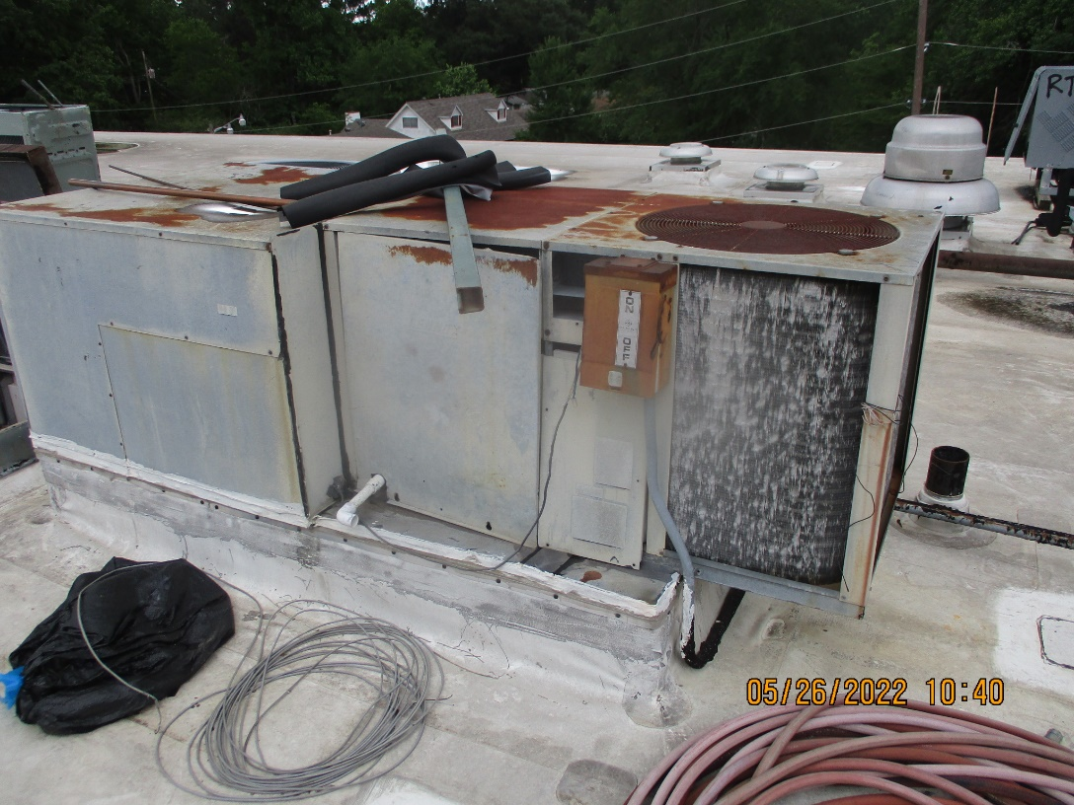
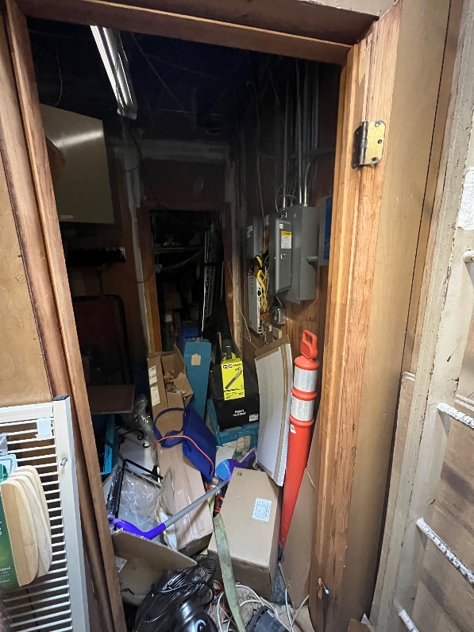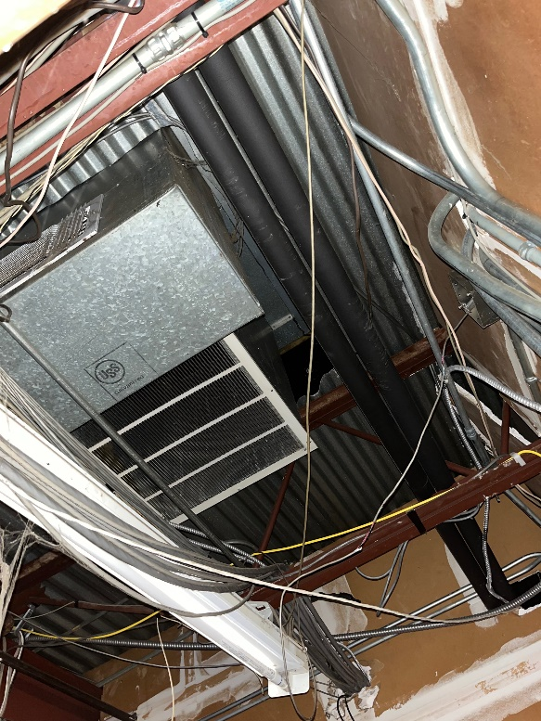

- we think the existing Aaon RTU shown in the attached photo serves the vestibule and customer service, is this correct? If NO, then what? That is correct

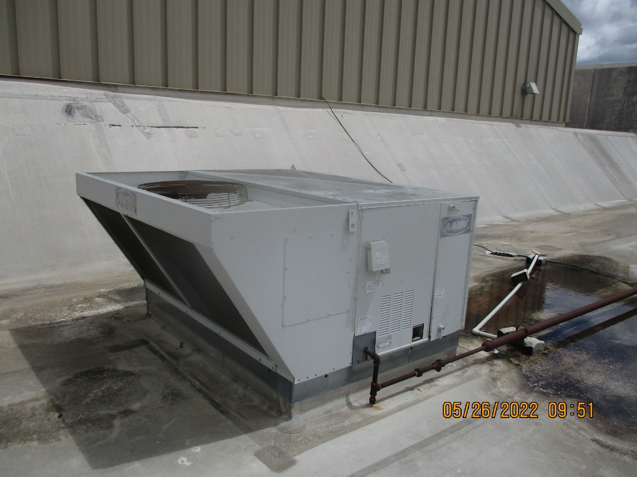

- we think the residential condensing unit shown in the attached photo serves a fan coil unit serving Pickup, is this correct? If NO, then what? That is correct.

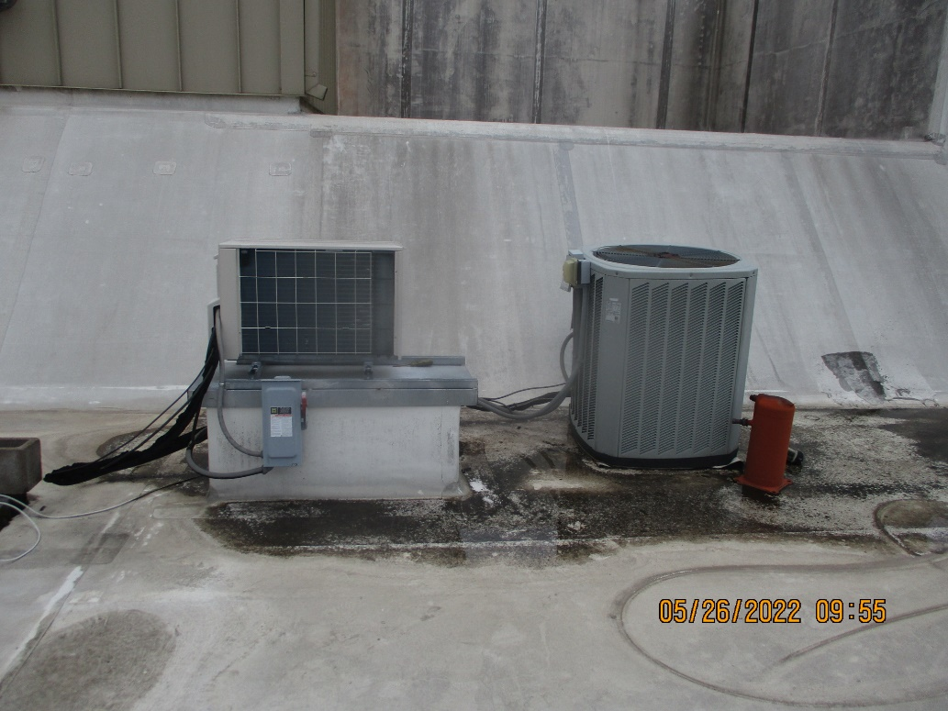

- Also need the structural information noted in red and green on the attachment. Have them call my cell if I’ve confused them. Cannot reach due to height of ceilings. Tall enough ladder or scissor lift not available.

