7-11 Floor Temp Snips 2-28-2024 9:00AM / weather was 36 degrees, cloudy and 52% humidity
1st Floor A side
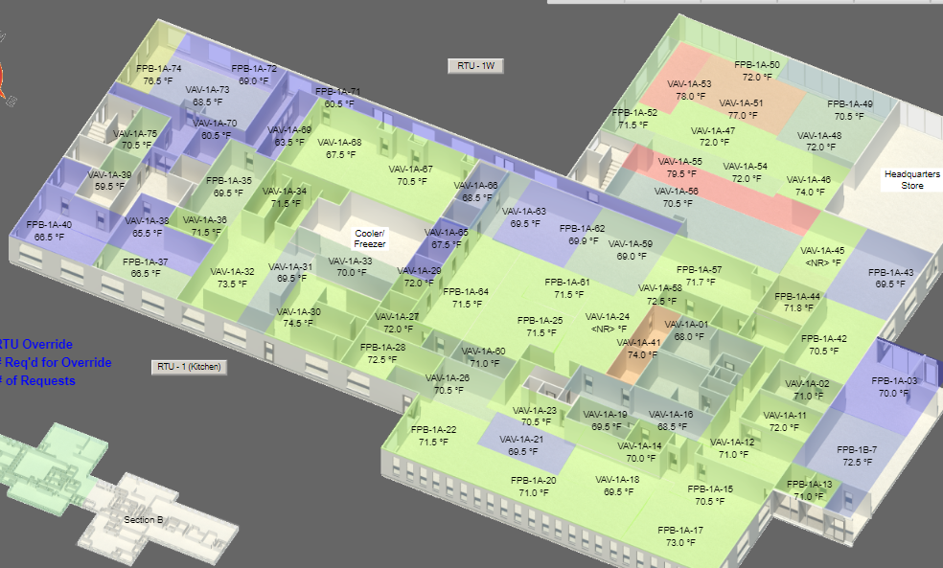
1st Floor B side
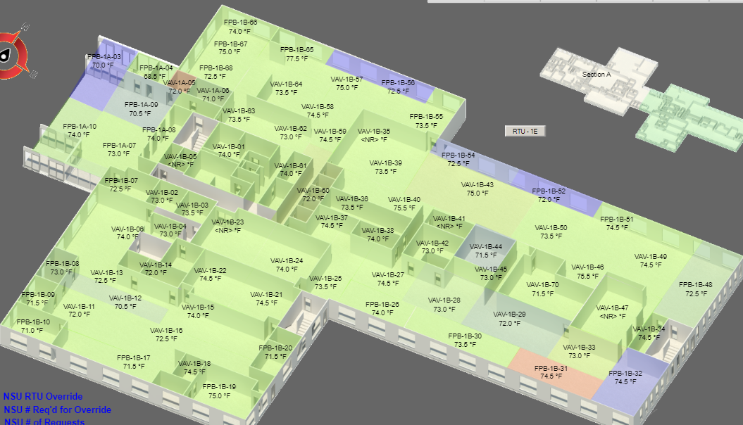

2nd Floor A side
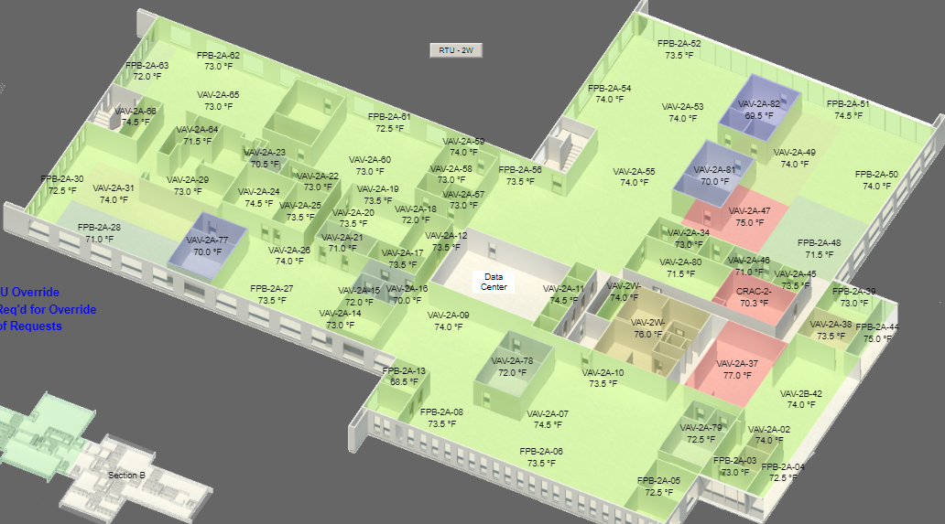
2nd Floor B side
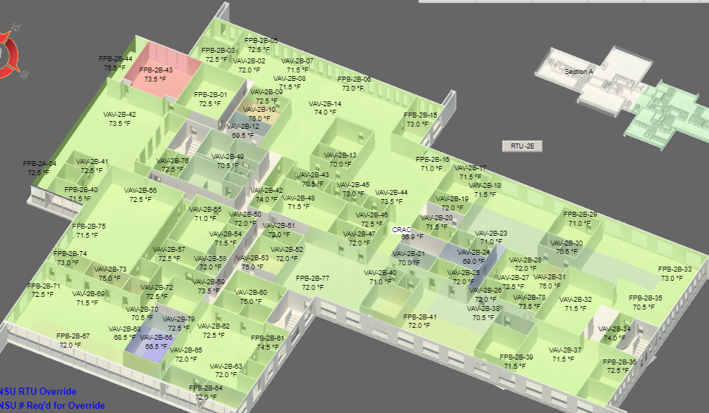

3rd Floor A side
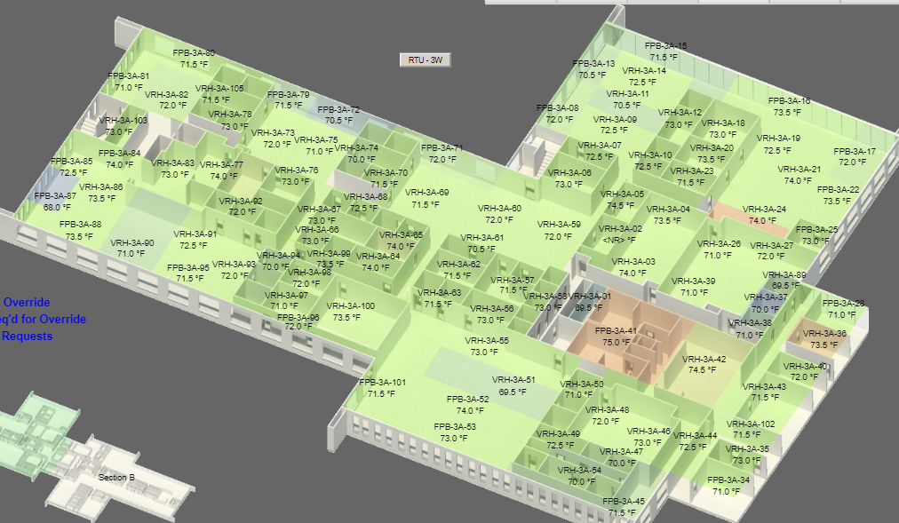
3rd Floor B side
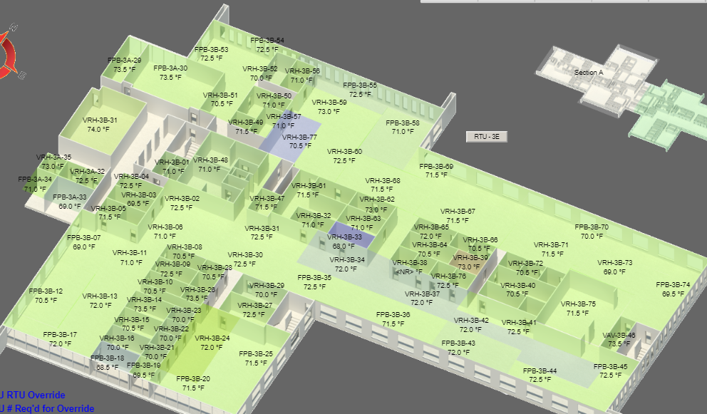

4th Floor
