7-11 Floor Temp Snips 2-27-2024 6:00PM / weather was 75 degrees, mostly cloudy and 74% humidity
1st Floor A side
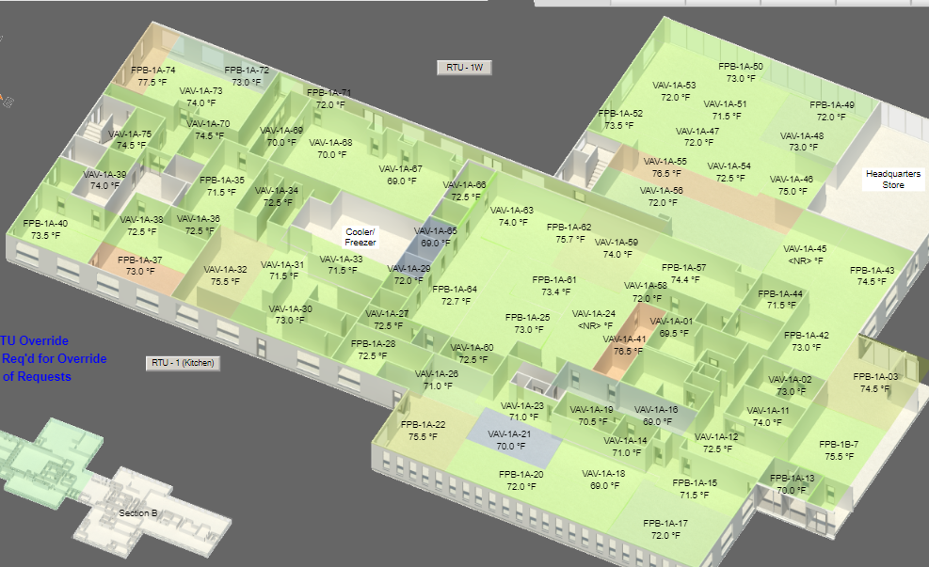
1st Floor B side
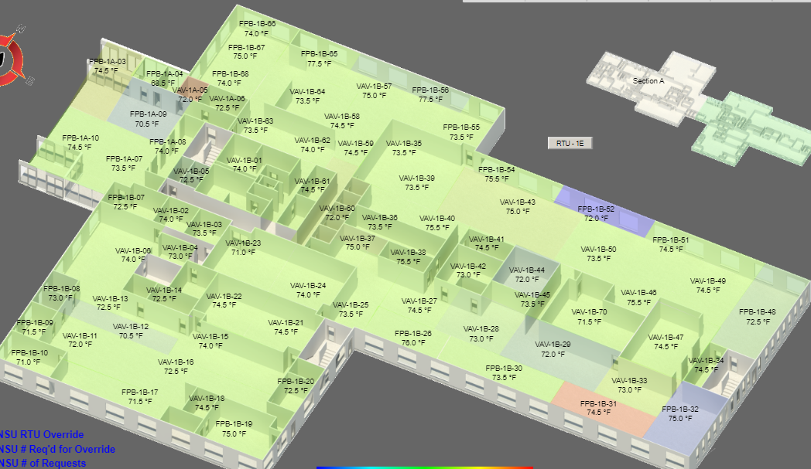
2nd Floor A side
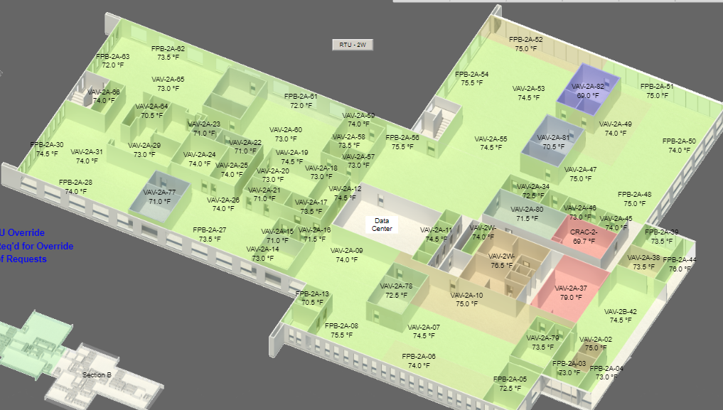
2nd Floor B side
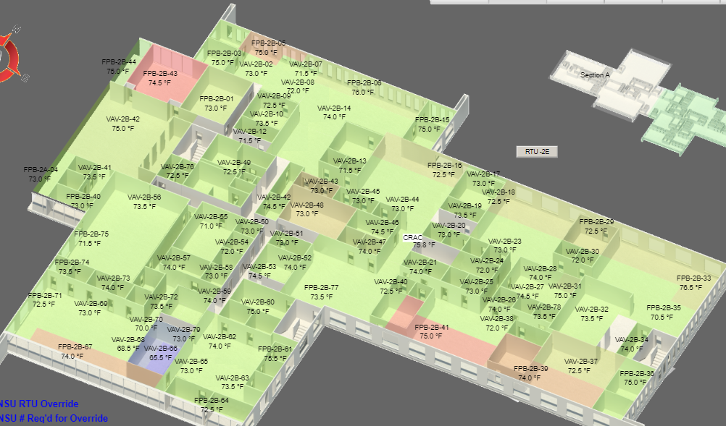

3rd Floor A side
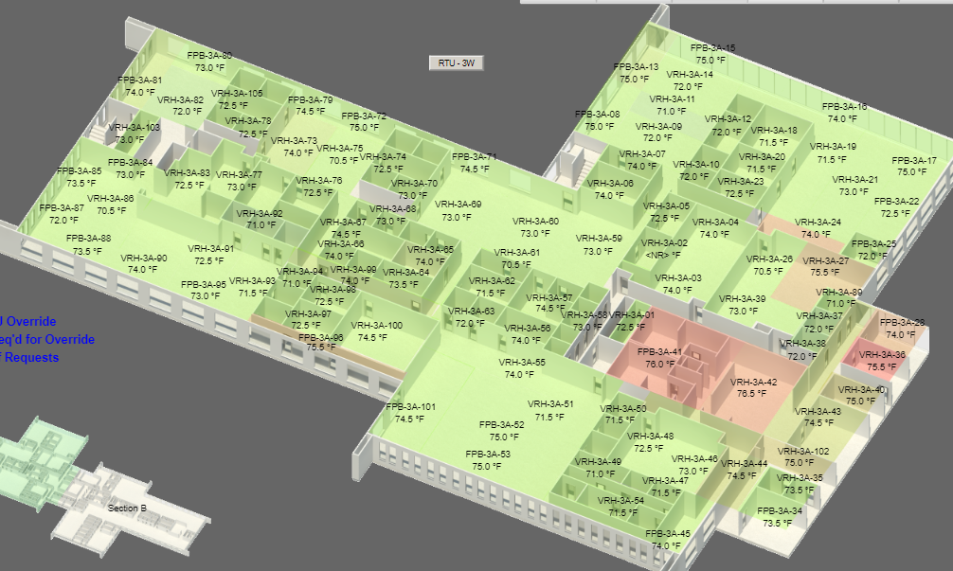
3rd Floor B side
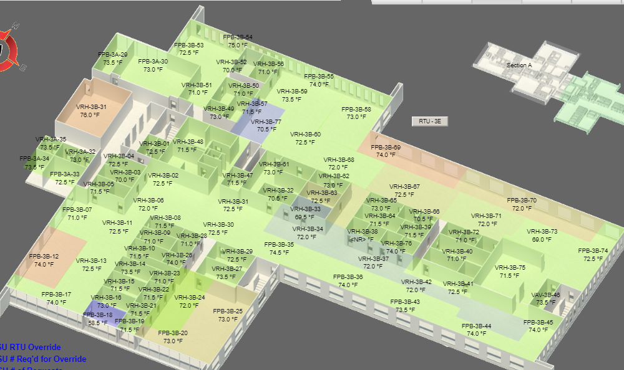

4th Floor
