7-11 Floor Temp Snips 3-4-2024 9:00AM / weather was 73 degrees, cloudy and 74% humidity
1st Floor A side
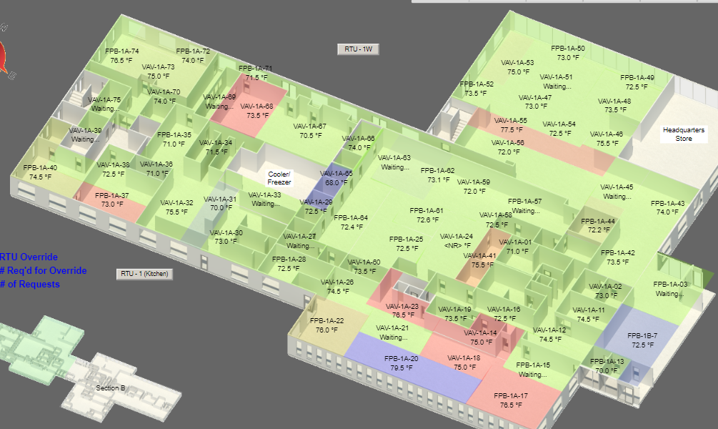
1st Floor B side
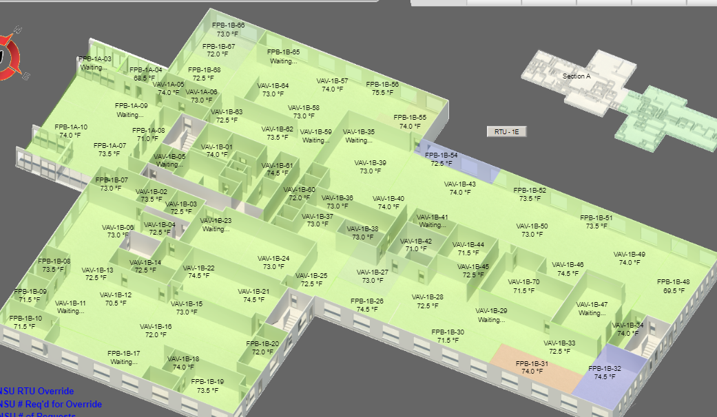
2nd Floor A side
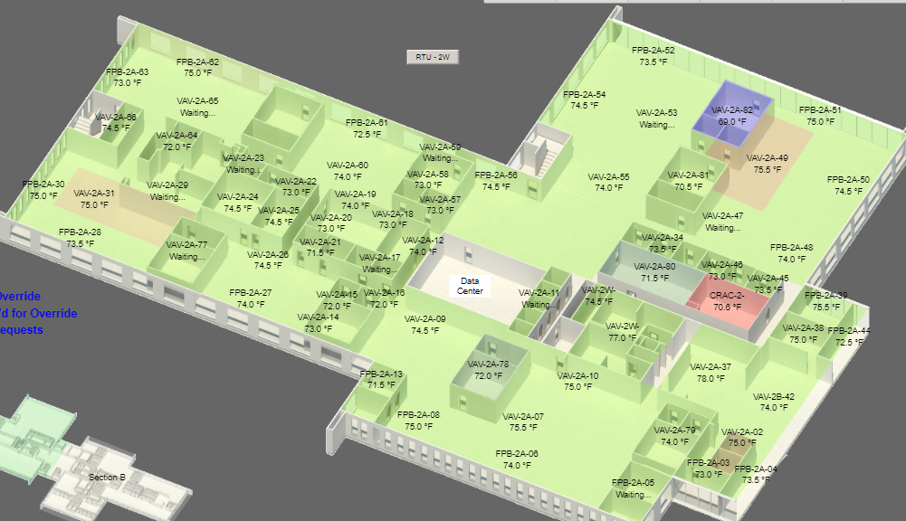
2nd Floor B side
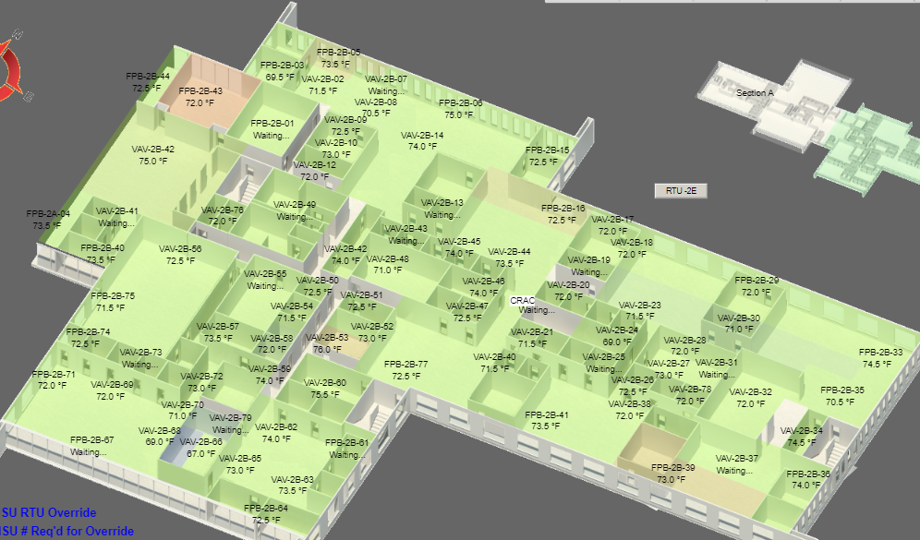

3rd Floor A side
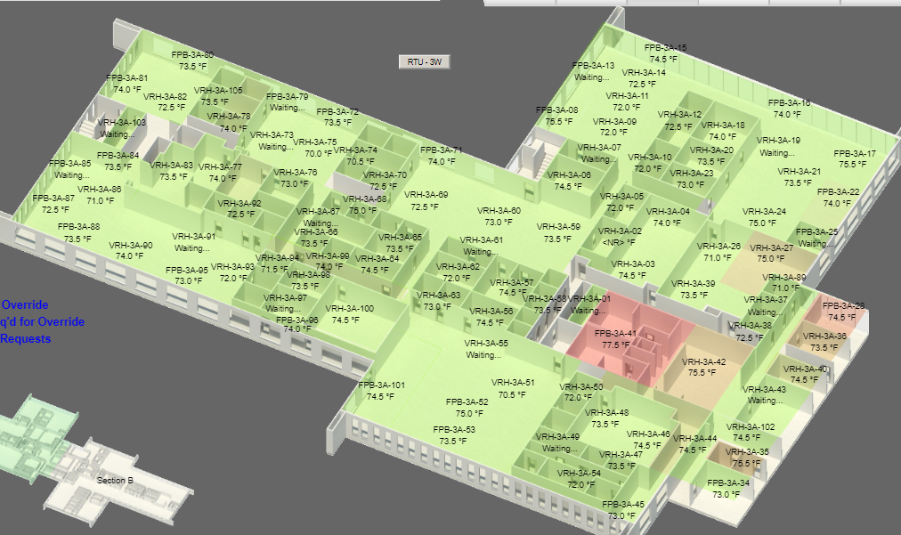
3rd Floor B side
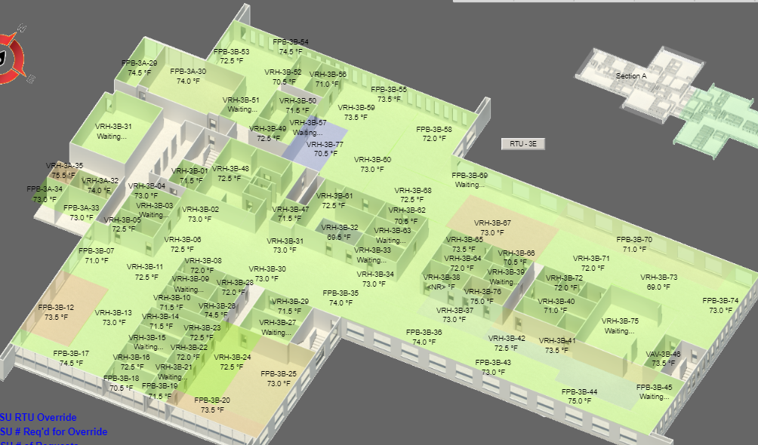

4th Floor
