PHOENIX CITY
Kitchen
Temp: 69.1F / RH 31.4% @ 9:04 am
Gateway S/N: BP5122000244 (NOT SHOWN OR UNSUPPORTED)
Temp S/N: 99f5
UNABLE TO MOVE TO PHOENIX CITY SITE OR TO CALIBRATE

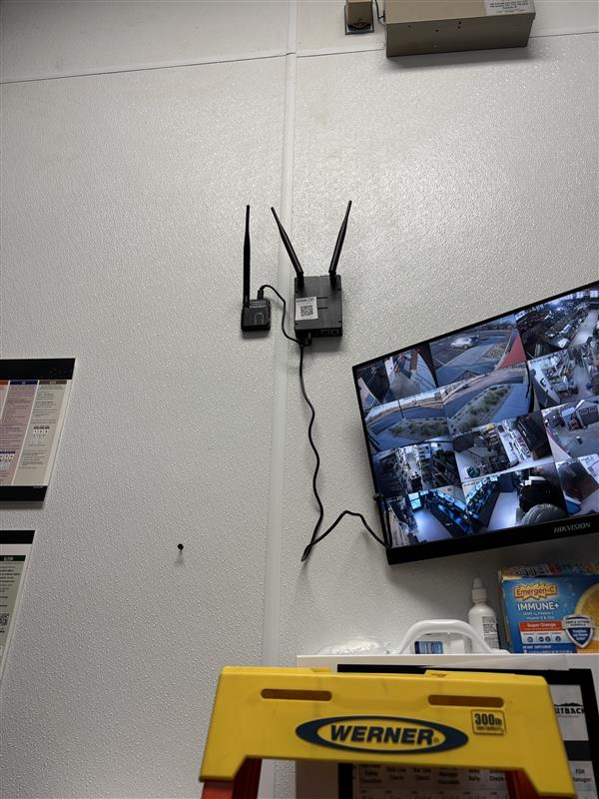

Dining
Temp: 70.5F / RH 26.2% @ 9:07 am
Gateway S/N: BP5122000147 (NOT SHOWN OR UNSUPPORTED)

UNABLE TO MOVE TO PHOENIX CITY SITE OR TO CALIBRATE

Temp S/N: 99a1
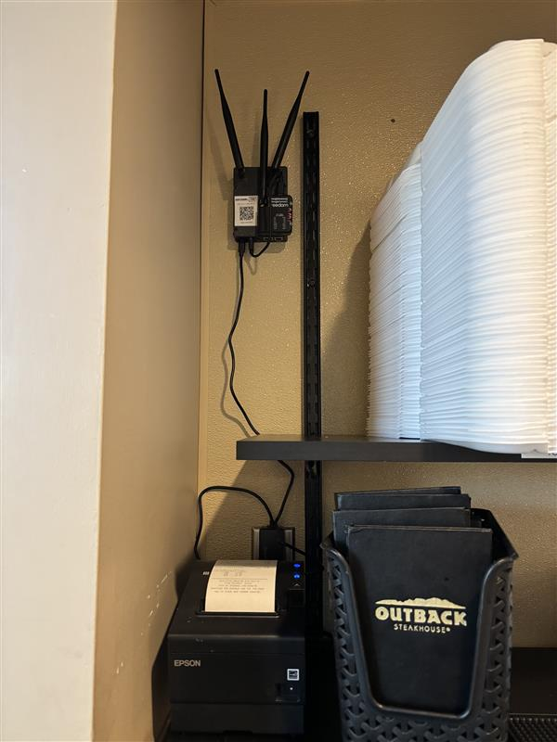

Model Number
RTU-1: KGC150S4MS1Y
RTU-2: KGC150S4MS1Y
RTU-3: KGC150S4MS1Y

RTU 1: Dining
MFG & S/N: Lennox / 5624H07027
M3: 21294e5
CT line: 29.8
Fan only blower: 7.7 A
Cool 1
Blower: 7.7 A
Comp1: 6.4 A
Outdoor Fan: 2.7 A
Cool 2
Blower: 7.7 A
Comp1: 7.4 A
Comp2: 10.6 A
Outdoor Fan: 2.7 A
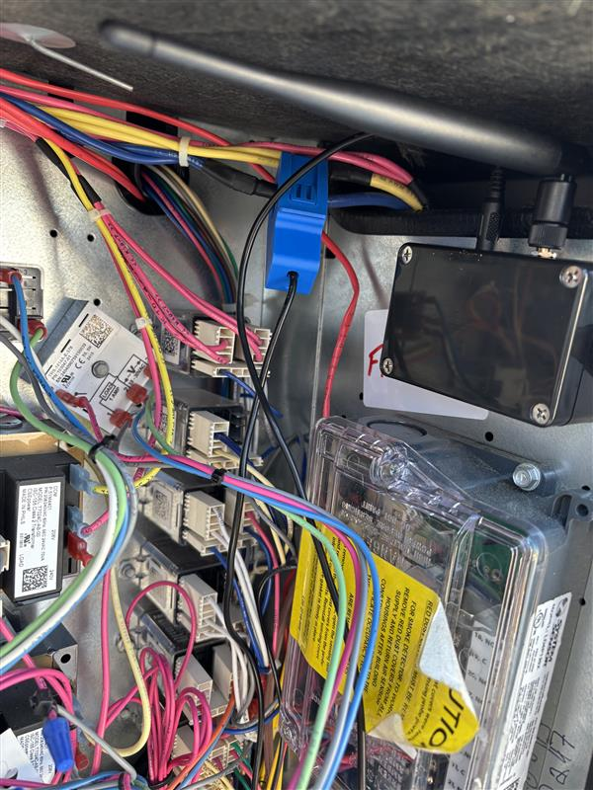

RTU 2: Dining
MFG & S/N: Lennox / 5624H07028
M3: 21294c1
CT line: 30.9 A
Fan only blower: 7.8 A
Cool 1
Blower: 7.8 A
Comp1: 6.3 A
Outdoor Fan: 2.9 A
Cool 2
Blower: 7.8 A
Comp1: 7.6 A
Comp2: 11.2 A
Outdoor Fan: 2.9 A
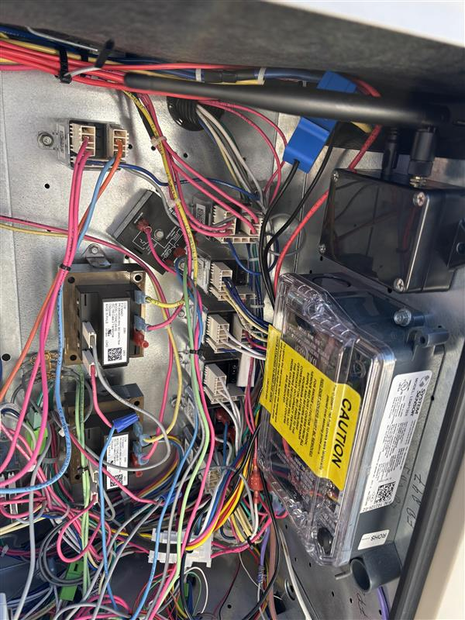

RTU 3: Kitchen
MFG & S/N: Lennox / 5624J05427
M3: 21294cb
CT line: 33.7 A
Fan only blower: 11.9 A
Cool 1
Blower: 11.9 A
Comp1: 10.6 A
Outdoor Fan: 2.8 A
Cool 2
Blower: 11.9 A
Comp1: 9.9 A
Comp2: 11.8 A
Outdoor Fan: 2.8 A
