Indian Hill High School
TAB PRETESTING
04/07/2023

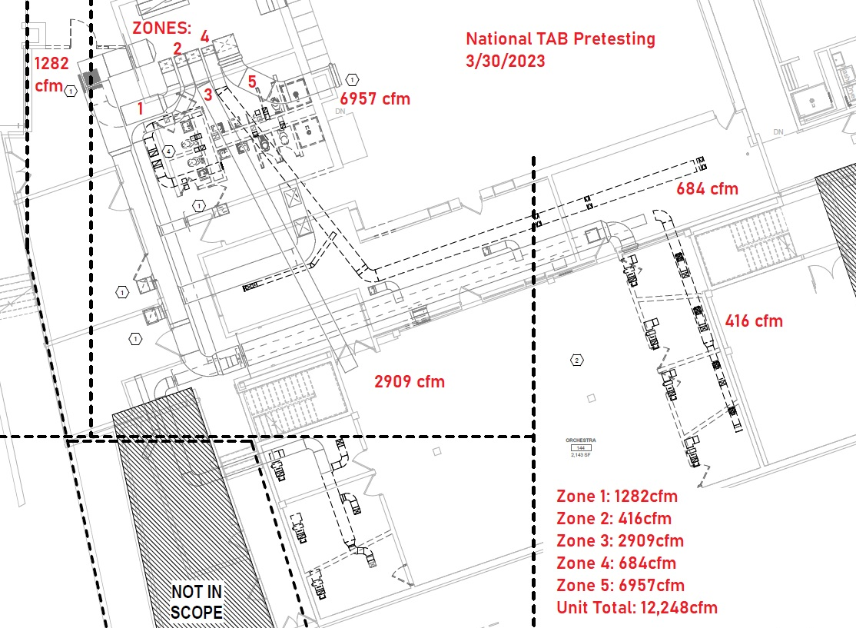
Testing preformed by first setting up the unit in full flow. All zone dampers and the OA damper were opened 100%, supply and return fan were commanded to 100%. All flows were gathered and reported below.

