PENN STATION (BURLINGTON, IN) SITE VISIT

Upon arrival to site I spoke with the Manager about his concerns with the space overall, his only concern was that the griddle hood would not capture 100%. He showed me spots on the countertop & ceiling where grease has been accumulated. I then took an initial building pressure of the space, -0.02”. The building was negative but within tolerance range. Space is right next door to a Nail salon which could be affecting the overall space. I took velocity readings at the filters and the average was 70 fpm. Filters were in decent shape; manager was doing a good job of cleaning filters every night.
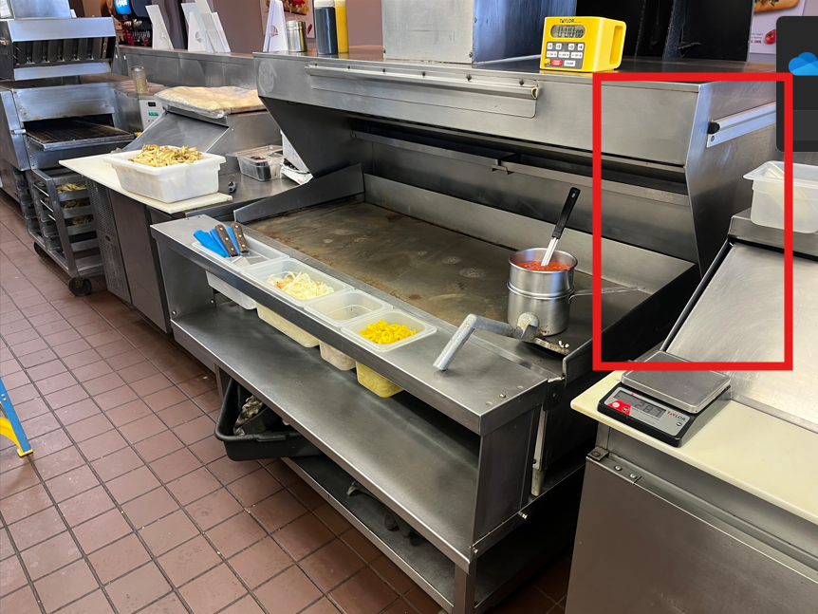
I then went to the roof to inspect the exhaust fan; the fan belt was extremely loose. Once I tightened the belt and went back down inside the space to take readings. New velocity readings had an average of 153 fpm. I think poured a little water on the griddle to see how capture looked. The capture was better, but there was still some rollout on the right side of the griddle hood.
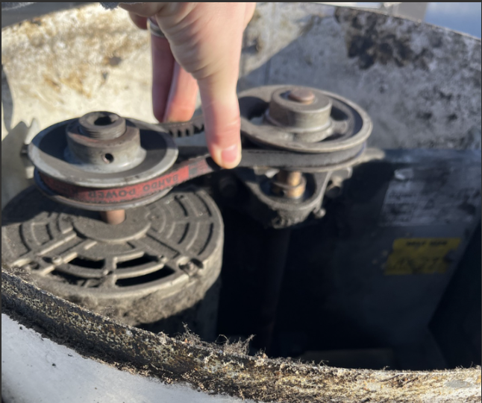
I then checked the airflows around the griddle to make sure they were still in design. These were the (2) 4-way diffusers located in front of the griddle & conveyor oven & the linear diffusers to the right of the griddle. All airflow were withing 10% of design. I went ahead and blocked of the 4-way diffuser to where the airflow was no longer being directed towards the hood. This helped with capture but there was still rollout on the right side, I would say 95% capture.
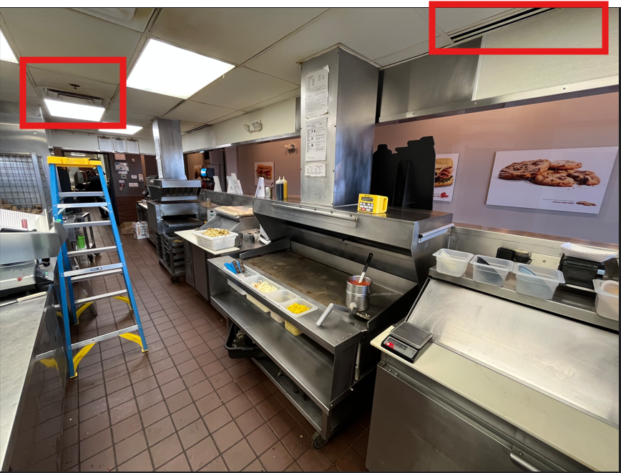
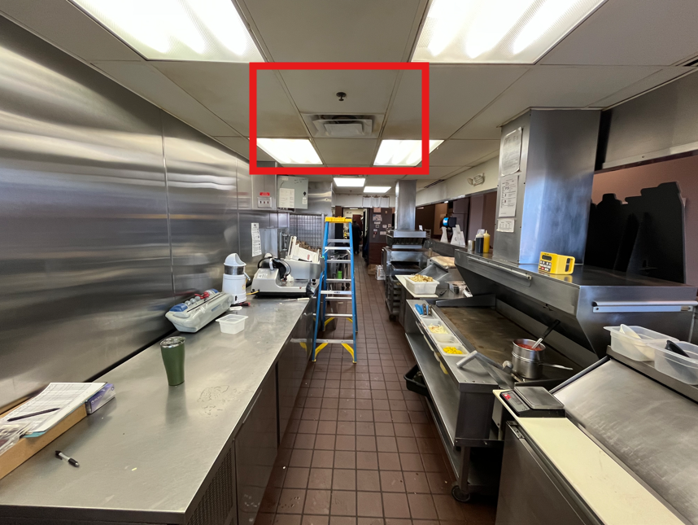
On the other side of the counter, there is a supply grille that is supplying air to the front of the store. In this area, there was a strong transfer of air from the front of the store to the kitchen area. I put some cardboard over the grille and had it closed about 50%. I could not feel the same velocity as before and I smoked the hood one more time. This time, the capture was 100%. I brought the store manager over to show him and he was very satisfied with the hood now.
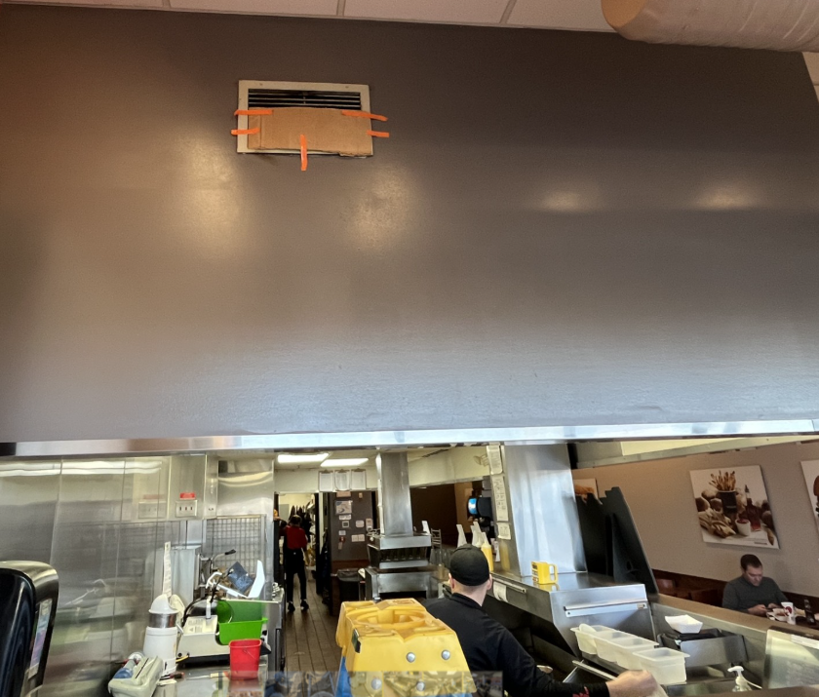

Recommendations:
- Change out the 4-way diffusers in the kitchen area that are located near griddle hood to perforated diffusers to lower the velocity of the airflow.
- Damper or cap 50% of the supply grille that is located above the front counter area so reduce the velocity and transfer to the kitchen area.
Items that need to be addressed:
- The disconnect on the griddle fan has been removed, the only way to turn the fan off is at the breaker.
- Look into replacing grease cup for griddle fan.
- Belt will need to be replaced soon for griddle fan.

