SWEETGREEN - ALDRICH ST., AUSTIN TX Commissioning Communication Plan

Communication & Collaboration
- Introduction
- Issue and RFI reports: Trigger conditions and resolution process
- IOS/Android Communication Platform Examples
  - Team Page
  - Issue & RFI logs
  - Checklist

Introduction

- Communication platform: FaciliBuild HUB
  - The platform (IOS / Android native application) can be downloaded on your phone or tablet. National TAB’s team will contact you to see if you prefer to use this method and if so, we will walk you through a quick onboarding process to get you registered and connected to the project where you will have access to:
      - All team members and contact information
      - Host all required digital checklist (FIV and FPT’s)
      - Host all issue/RFI items

Issue and RFI reports: Trigger conditions and resolution process

Issue reports are generated during the field inspection (FIV) Phase I scope, and during any failed FPT of equipment/systems.
Process for Issue resolution, Issue(s) are created for reasons below:
      - Not installed
      - Not Installed to plan/schedule/spec/submittal/detail/special provisions (code-OEM requirement)
Resolution: GC will be issued a report at the conclusion of the inspection, and if available, made aware during the inspection. CxA will follow-up with GC to ensure the issue has been resolved.
RFI Reports are generated during the same inspections and are created for reasons listed below:
      - Condition cannot be met
      - Local AHJ supersedes Design
Resolution: RFI will be discussed with GC then sent to Engineer of record to accept or detail response which may require new shop drawings should major deviations in system layout occur.

EXAMPLES OF FACILIBUILD HUB APPLICATION
TEAM
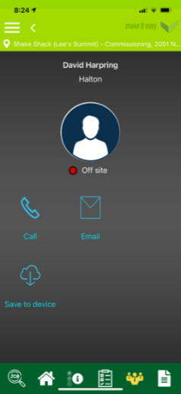
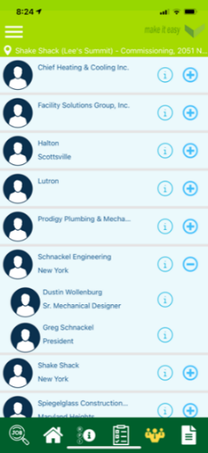
All Team members & Trades assembled onto team page for easy access and communication – Allows all members to see electronic checklist, issues and necessary information as it occurs

Checklist
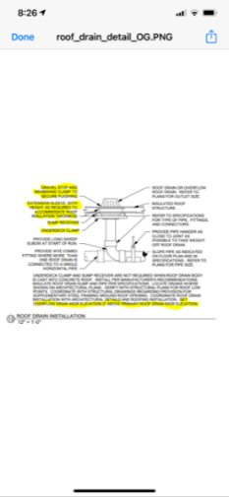
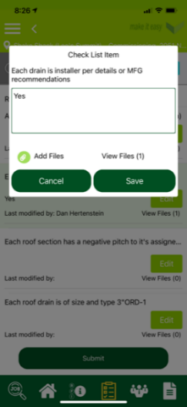
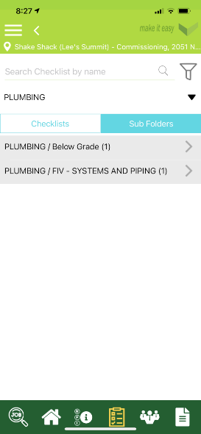
All FIV, OPT, & FPT checklist are created stored and completed on the platform. Allows video, file, and picture upload of test or condition and is assigned and shared to anyone on the team

RFI & ISSUES
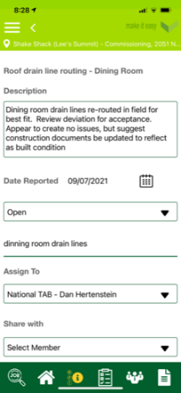
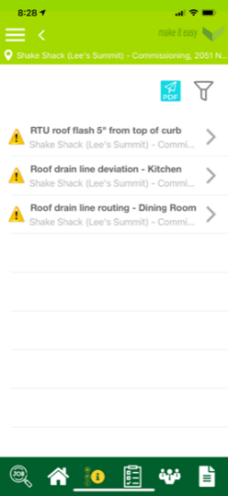
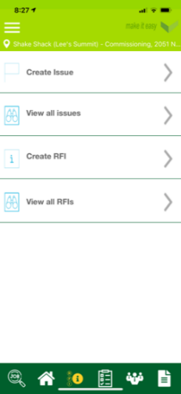
All RFI and Issue action items are created stored and completed on the platform. Allows video, file, and picture upload of condition and is assigned and shared to anyone on the team

