SUMMARY (Rusty Keg Evaluation April 2024)
The objective for the evaluation was assist in finding solutions for known issues and also to evaluate the HVAC systems for overall assessment of the systems. Below is the list of items that were known or uncovered during the evaluation. Enclosed are sketches, pictures, and testing data to assist in next steps to improve comfort and performance of the HVAC & Hood systems.
Items to address
- Hood performance, specifically the fryer/griddle hood
- Building pressurization
- Kitchen HVAC performance
- Dining RTU duct tie into the kitchen system not ideal.
- Overall ductwork distribution for HVAC systems is inadequate.
- Owner concern about energy cost currently
Discussion of each item
- The main issue with hood performance for the fryer/griddle hood is the type of hood. It is currently a short cycle hood that introduces non-tempered air into the hood affecting hood performance with 50% capture rate. By turning off the make up air, the hood performance increases up to at least 85% capture rate. By doing this it in essence turned the hood into an exhaust only system. We then installed an end panel (mocked up) on the left end of hood & it improved capture to 95%. The only impedance is the utensil bin above the warmer to the left of the fryer. Smoke (affluent) gets caught below the area & then since its partially outside of the hood, it allows smoke to roll out from under the equipment & then into the kitchen. IF this bin can be removed & a panel size of 40” (top) x 22” (bottom) x 30” H (verify height once cut & what can be done without impeding operations), would allow for 100% capture as long as no forced drafts (fans to keep cool) are directed at the hood system. The other (2) hoods are end to end and do not have any hood performance issues. This is because the make up air filters on the roof are so clogged with debris/dirt that both fans are barely bringing in any outside air. In essence, the (2) hoods are acting basically like exhaust only hood systems. Cleaning supply fan filters is a good maintenance procedure, but it will impact hood performance.
- Hood performance was improved by basically making all the hoods exhaust only systems. The issue is that does create even more of a negative pressure to the space.
Initial Building pressure with SF3 (fry/grill hood) ON was -0.035” front & -0.055” back door.
Building pressure with SF3 OFF is -0.058” front & -0.067” back door.

The space is more negative than measured. Recently the facility installed a couple of eggcrate(s) in front of the fryer/griddle hood which is exposed above the drop ceiling (no duct connected) & the roof deck. The facility has multiple vents that allow outside air to be pulled in directly from the roof deck & then through the ceiling via eggcrate into the kitchen area. While this helps with alleviating some pressure issues it causes uncontrolled hot/humid or cold air to be introduced into the space. Below are the current conditions of the facility.
(*) Estimated filter was clogged.
(**) first # is with SF3 on & second # is with SF3 off. With SF3 on, hood performance deteriorated dramatically.
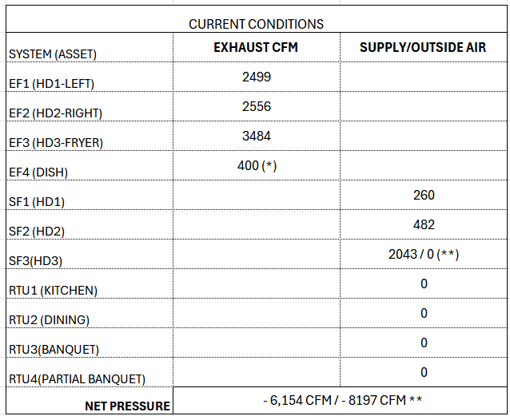
To assist in building pressure without degrading the performance of the hood system, a dedicated make up air system that introduces outside air when the hood systems are on in a controlled methodology and to reduce the load to the space as much as possible. Below is a recommended new air balance schedule with introducing a new heated make up air system. The owner would be required to also purchase and install front stainless steel perforated supply plenums in front of all (3) hoods to distribute the make up air. With the end panel(s) on, doors closed to the banquet area the exhaust level can be reduced some on all three hoods. SF3 would be replaced with the heated system & SF1 & SF2 would be eliminated to help with reduction in energy consumption. A heated system must be provided at minimum when air is introduced outside of the hood. It is recommended that it is cooled also to help with better comfort in the summertime, but this is a decision the owner should make based upon initial cost vs the desire to keep employees more comfortable. By cooling the make up air down would most likely keep the employees from turning the banquet RTU unit down to 68 degrees and opening double doors to stay cool. The banquet room is only utilized at most 24 hours a week. So, the run time is probably 5 times longer when it starts getting warmer (70 degrees or above outside) than it should be.

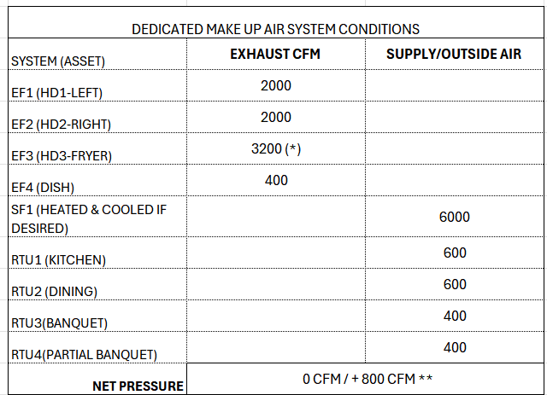
- There is a large support beam near the current SF3 that can help support the heavier unit.
It would also require installing outside air (simple manual intakes) into each of the RTU units to allow for a minimum amount of outside air into the unit to help with overall pressure to the space. It would not impact the unit, provides better IAQ to entire space and can be done economically.
Another option is to remove the all (3) untempered supply fan & replace the Kitchen RTU unit with a new larger RTU-DOAS unit that would condition the entire kitchen area, also aid in conditioning some of the dining area. It would allow for independent operation of the hood systems. The unit would condition the space and as each hood turns on & off the outside air would open to provide a balanced system. Weight consideration & location on the roof would have to be looked at by the team. No supply plenums would need to be installed in front of the hood systems. However, some additional air devices would need to be ducted off the existing supply duct system. It would also allow for the hood exhaust to be lowered slightly more than the above option. Below is recommended air balance schedule.
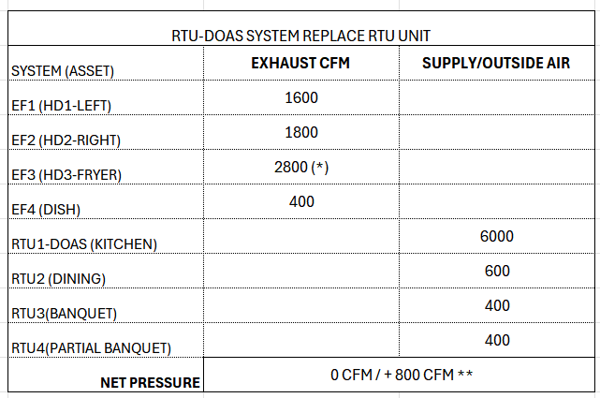
3/4/5. While performing the assessment of the HVAC systems for the facility it became evident that the duct distribution system is not optimal. See the enclosed sketches of the HVAC Duct systems. The Kitchen RTU unit has a main supply drop into the kitchen & then branches off in two directions. One heads towards the back of kitchen & the other one heads towards the front of kitchen & all the way into the bar & over dining area. The branch line (OD) going to dining area is 12 x 26. The Dining RTU unit does not have its own supply duct system. It is just ducted straight into the same 12 x 26 branchline that the kitchen unit serves. This is a big impact to each of the systems. The Kitchen unit is a 10-ton unit & the Dining additional unit is a 7.5 ton unit. The max airflow (IF aligned with 1” internal insulation) 2500 CFM. Both units are trying to distribute air to this branch line impeding performance of both units. Both systems should have there own dedicated supply trunklines and be zoned to operate and run only when needed (occupied).
The branchlines going to each of the air devices are all flex duct. While this allows for easy installation, it does add resistance to the branchline and reduce airflow rates. Another recommendation is to at minimum is to reduce the flex for any runs that are more than 20 ft or have crimped duct in the flex. Typically, hard pipe is ducted to at least 10 ft from each air device and then flex is sometimes used to the air device. Most likely the office, main entry, and bathrooms get quite warm during the summer months. Very little airflow is distributed to these areas. There is a about a 50 ft flex duct that ducted off the same 12 x 26 branchline above the bar & routed to entry area where there is a sheetmetal box & 5 diffusers that are branched off the box. Very little airflow is introduced to each of the supply diffusers.
One final observation on the distribution system is that the RTU that serves the ALLSTATE space also serves several air devices in the storage & banquet areas.

- There could be overall energy savings and definite facilities performance with modifications to the HVAC & Hood systems. As the team considers options for best ROI each step can have an impact on energy. Anytime you can reduce exhaust levels, eliminate motor run time, and eliminate the need to pull in undesirable untempered humid/hot or cold air into the space are direct impact on energy and comfort for employees and customers. Run time of HVAC systems can be impactful to energy cost. The owner should make effort to reduce or eliminate the need for employees to supplement the kitchen cooling by using the HVAC for the banquet areas when it is not occupied and adding additional fans & keeping the double doors open that impact hood performance. Ductwork for the dining & kitchen unit needs to be resolved to improve performance of both units and provide better comfort throughout the space.

